

**Hazelbank Road, Catford, London, SE6 1TG**

**Headteacher: Manda George**

**Telephone: 0208 697 2762**

**Email:** [**admin@torridonprimary.lewisham.sch.uk**](mailto:admin@torridonprimary.lewisham.sch.uk)

**Website:** [**www.torridonprimary.lewisham.co.uk**](http://www.torridonprimary.lewisham.co.uk)

**Twitter: @TorridonPrimary**

4th November 2022

Dear parents and carers,

Welcome back to the second half of the autumn term. I hope you all had a lovely half term break and got the chance to spend time with loved ones.

We have had a great start to our new topics. The children are very excited about the learning for this half term. Curriculum bulletins and home learning leaflets are available on the school website and via MS Teams. As always, please speak to your child’s class teacher if you have any questions about the learning.

Thank you to those who have volunteered to come and join the green team tomorrow for some weeding, pruning and planting around the school grounds. Fingers crossed the weather is as beautiful tomorrow as it has been today.

I hope to see you at the PTA coffee morning on Thursday. It will be fantastic to hear your ideas and suggestions about fundraising and events.

If you are attending or holding a fireworks event this weekend, have a lovely time but please stay safe.

Have a wonderful weekend.



Best wishes

Manda George

Headteacher

**Divali**

****We know that many of you will have celebrated the Festival of Lights last week. We hope you had a wonderful time.

Divali honours Lakshmi, the Hindu goddess of wealth. It is said that the Divali lamps are to light her way into people’s homes and bring prosperity for the year to come.

**Dates For Your Diary**

|  |  |
| --- | --- |
| **Saturday 5th November** | PTA Gardening Day |
| **Monday 7th November** | Early Reading Workshop for parents and carers (9am) |
| **Thursday 10th November** | PTA Coffee Morning |
| Children in Need launch assemblies |
| Resource Base visit to Forster Park |
| Year 2 SATs meeting for parents and carers (5pm) |
| **Friday 11th November** | Armistice Day |
| **Week beginning 14th November** | Anti-bullying week |
| **Monday 14th Novermber** | Odd Socks Day for anti-bullying week |
| **Tuesday 15th November** | Resource Base Primary Panathlon |
| **Wednesday 16th November** | Year 6 to Tate Britain |
| **Thursday 17th November** | Year 4 Multiplication Check meeting for parents and carers (5pm) |
| **Friday 18th November** | Children in Need |
| **Monday 21st November** | National Child Measurement Programme |
| **Wednesday 23rd November** | Y3/4 Girls’ Football Tournament |
| Y2 to London Zoo |
| **Thursday 24th November** | Year 1 Phonics Screening Check meeting for parents and carers (5pm) |
| **Friday 25th Novermber** | **INSET DAY** |
| **Week beginning 28th November** | Whole school assessment week |
| **Tuesday 29th November** | Y5/6 Girls’ Fotball Tournament |
| **Wednesday 30th November** | Flu Immunisation Programme |
| **Monday 5th December** | Resource Base to Lewisham Bus Garage |
| **Tuesday 6th – Thursday 8th December** | Art Exhibition |
| **Thursday 8th December** | Christmas Disco |
| **Friday 16th December** | Last Day of Term (2pm Finish) |
| **Tuesday 3rd January** | **FIRST DAY OF THE SPRING TERM** |



**Mobile Phones**

Mobile phones are only allowed in school if year 6 children are walking to and from school by themselves. Phones must be switched off before children enter the school premises and handed in to a member of staff in their classroom. Phones must not be kept in bags or pockets. Any phones that are not handed in will be confiscated, and the parent or carer will be contacted. **Children in other year groups must not bring mobile phones to school.**

Thank you for your support.

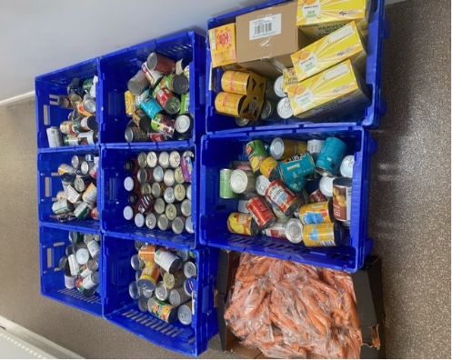**Harvest Festival donations**



We would like to send a big thank you for all those who donated to the harvest festival! You made a very big difference to families in need over the half term holiday.

Thank you – we are extremely grateful for your generosity!

**PTA**

**Please see the link below for the latest newsletter from the PTA.**

[**Friends of Torridon PTA Autumn Term Newsletter**](https://mailchi.mp/de3bd7af3812/autumn-term-newsletter)



**Stars of the Week**

*Week commencing 31.10.22*

|  |  |  |
| --- | --- | --- |
| **Class** | **Name** | **Reason** |
| Nursery FT | Alaia | For always following Nursery rules and for always helping her friends. Well done, Alaia! |
| Nursery AM | Thaarani | For exploring the Nursery environment and for always being kind to her friends. Well done, Thaarani! |
| Red Class | Kasper | For constantly demonstrating a positive attitude to learning and showing great progress in maths and phonics. |
| Blue Class | Kyrie | He has worked so hard on writing his name this week and is constantly a good listener. Amazing work Kyrie! |
| Yellow Class | Thanushika | She always has a positive attitude to learning and is kind to others. Well done! |
| 1G | Navpreet | For her excellent attitude to learning! She is gaining independence and is making so much progress, well done. |
| 1M | Kruz | For his growing independence in writing and trying his best. He has made fantastic progress, well done! |
| 1N | Cassia | For her newfound confidence and excellent writing. She has made great progress and made us very proud! |
| 2G | Josann | For her amazing contributions and creativity in her writing! Keep it up Josann😊 |
| 2S | Ria | For all of the fantastic learning she has produced this week! Well done for staying focused and trying your best 😊 |
| 2SW | Orel | For always putting effort into her learning and always trying her best. Well done Orel! |
| 3A | Jeraiah | For working so hard in all of our lessons and showing excellence in the daily mile too!  Well done. |
| 3L | Bea | For working hard on her focus, contributions in class and playing happily with others. Fantastic! |
| 3S | Kenny | For making insightful comments during English. Thank you for always trying your best! |
| 4C | Anna Lydia | For showing excellent behaviour and trying her best to make the right choices. |
| 4V | Joseph | For showing great improvement in his learning behaviour. |
| 4W | Zohal | For remembering to bring in her reading record every day since the start of the year. Continue to maintain an excellent attitude learning. |
| 5L | Ashanti | For consistently demonstrating a positive attitude to learning. She is a great example of someone who tries her best within her learning. Well done Ashanti! |
| 5R | Sukhmani | For amazing effort in all her learning. |
| 5S | Aaliyah | For continuously showing excellence in her behaviour and for always producing excellent work. |
| 6A | Olivia | For consistently displaying the core value of excellence in all areas of her learning. She’s an excellent role model for Torridon. Keep it up! |
| 6C | Samaya | For demonstrating excellence in your learning. You have been working hard on your arithmetic skills in maths – well done! |
| 6L | Norah | For always having manners and being respectful. You are always so helpful and willing to help out around the classroom – thank you! |
| RB Blue | Dalrekay | Well done for integrating so well into class this week and playing so nicely at playtime! |
| RB Green | Raphael | Well done for doing so well in Year 1 this week. You have also been playing so nicely with other children which has been lovely to see! |

**Hats and Gloves**



As the weather starts to turn colder, children will want to wrap up warm in hats, gloves and scarves. Please make sure that all items are clearly labelled with your child’s name and class. We do not want items of clothing going missing.

Many thanks

**Nursery Art**

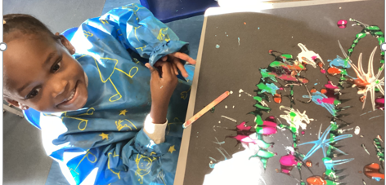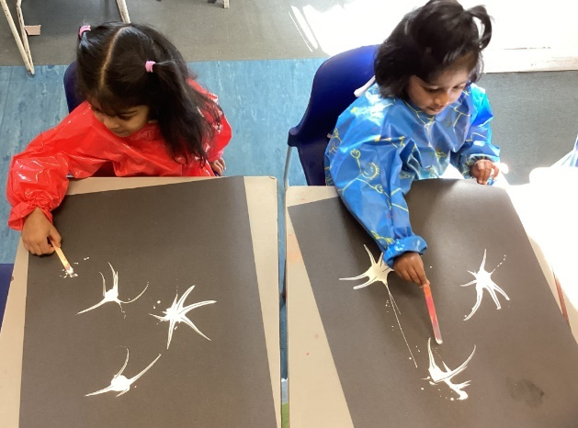

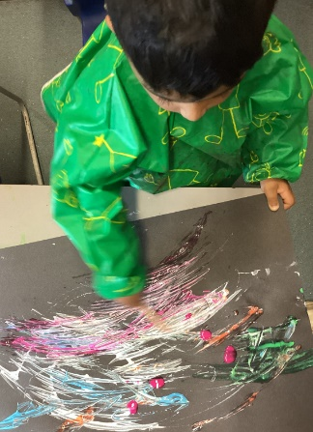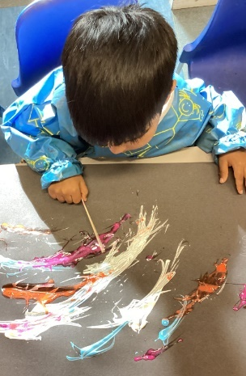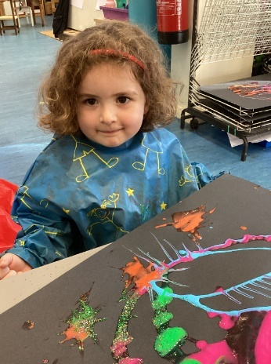**Nursery had a fun day learning about fireworks. We watched some videos and talked about the colours and sounds. Then we had a go at painting them, thinking about the shapes as well.............and then added some gorgeous glitter!**

**Early Reading Workshop**

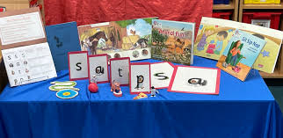We would like to invite parents and carers of children in Reception to attend a workshop to give further information about phonics and early reading.

This will take place in the **KS1 hall Monday 7th November 2022 at 9.00 am**, after drop off please come and join Becki in the hall.

**New Autumn / Winter 2022 Menu**

Please ensure all dinners are paid a week advance. If you need any support with payments, please contact the office.

Please note that termly costs for school dinners are as follows:

|  |  |
| --- | --- |
| 31st October – 4th November | £11.50 |
| 7th – 11th November | £11.50 |
| 14th – 18th November | £11.50 |
| 21st – 24th November | £9.20 |
| 28th November – 2nd December | £11.50 |
| 5th – 9th December | £11.50 |
| 12th – 16th December | £11.50 |
| TOTAL TERM 1 | £78.20 |

**PTA Coffee Morning**

**PTA Coffee Morning - Thursday, 10th November**  
Join us after drop off for an informal social gathering: get to know other parents and carers, find out about PTA events, and share your ideas about how we can improve the school for our children and community. Hot drinks and light snacks will be available free of charge. At this half term's coffee morning we'll share our early plans for the disco and sort uniform donations ahead of the next sale.

**Parent Governor Elections**

*Congratulations to Andy Tinker Switzer who has been elected as a Parent Governor. Andy joins a strong team of parent governors and I look forward to working with them on how the governing board and the school communicate with all our parents and carers.*

*Margaret Brightman, Chair, Governing Board*

**Reception Cooking Club**

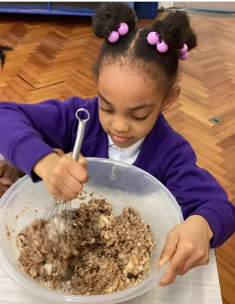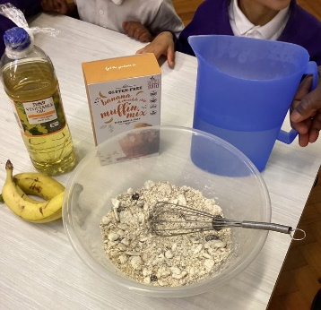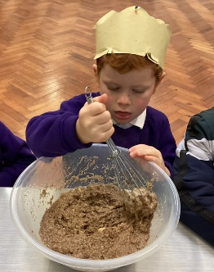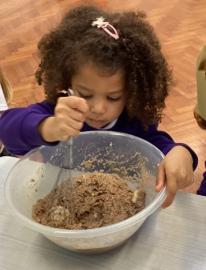

**This week we made healthy, vegan, dairy free, banana, chocolate chip and oat muffins.We had so much fun mixing all the ingredients together and watching the muffins cook.**

**Winter Activity Camp**

