

**Hazelbank Road, Catford, London, SE6 1TG**

**Headteacher: Manda George**

**Telephone: 0208 697 2762**

**Email:** [**admin@torridonprimary.lewisham.sch.uk**](mailto:admin@torridonprimary.lewisham.sch.uk)

**Website:** [**www.torridonprimary.lewisham.co.uk**](http://www.torridonprimary.lewisham.co.uk)

**Twitter: @TorridonPrimary**

11th November 2022

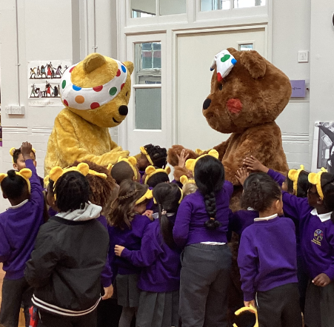Dear parents and carers,

What an exciting day we had yesterday! You may have seen that we had some very special guests in the playground at the beginning of the day. We were lucky enough to meet Pudsey and Blush from BBC Children in Need. We had special assemblies and all took part in a Joe Wicks workout with our furry friends. Pudsey and Blush came to Torridon to tell us all about the fantastic work that Children in Need do to help families and how the money that is raised supports children who need it most. We are hoping to help them to raise money next week when we take part in a dress up day on Friday and donate whatever we can afford to support children all over the UK.

We will be celebrating Anti-Bullying Week next week. It take place from 14th to 18th November and has the theme ***Reach Out.*** Children will be exploring how to empower themselves to do something positive to counter the harm and hurt that bullying causes. We will be discussing how to reach out to someone you trust if you need to talk, how to reach out to someone you are concerned about and how to reach out and consider a new approach to deal with a situation. The week will kick off with Odd Socks Day on Monday 14th November, where children and our Torridon Community, are invited to wear odd socks to celebrate what makes us all unique. I will also be working with the school council who will be helping me to review the anti-bullying policy so we can ensure that Torridon is a ‘bullying free zone’.

Thank you to those of you who attended the PTA coffee morning this week. It was a very busy session, sorting some of the donated uniform ready for resale next month. Your help is greatly appreciated.

Thanks also to all who attended our parent workshops this week for phonics and Key Stage One Assessment. I hope you found them useful. Next week, we are inviting year 4 parents and carers to come and find out about the Muliplication Tables Check. Look out for more parent workshops planned for the spring term.

I hope you have a wonderful weekend!

Warm wishes

Manda George

Headteacher

**Armistice Day**



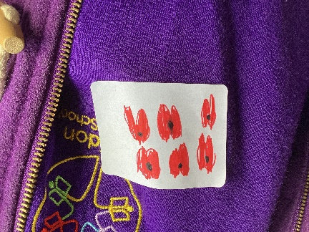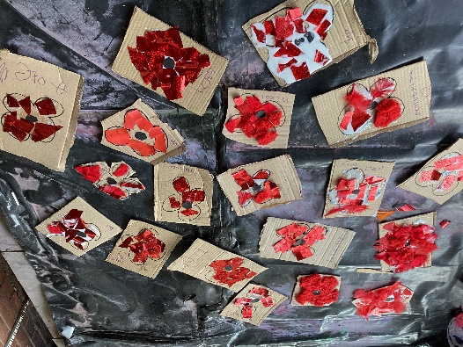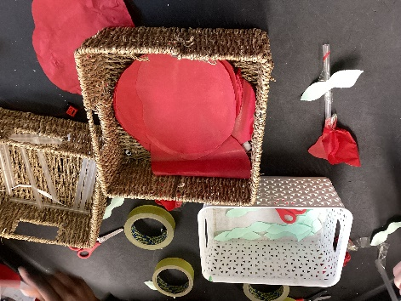

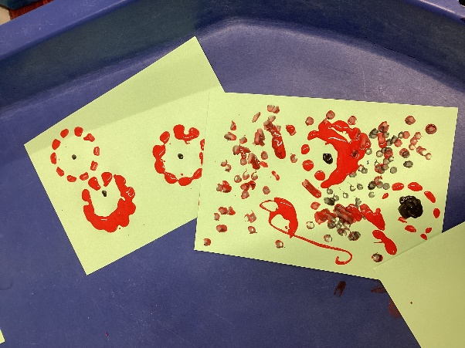

**We hed special assemblies today to mark armistice day and to remember the soldiers who gave their lives for their country. We held a 2 minute silence to reflect and honour them.**



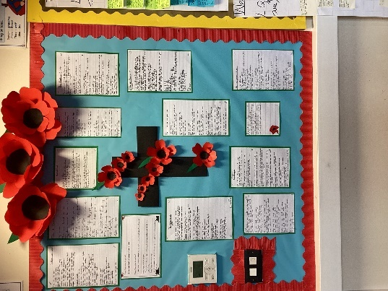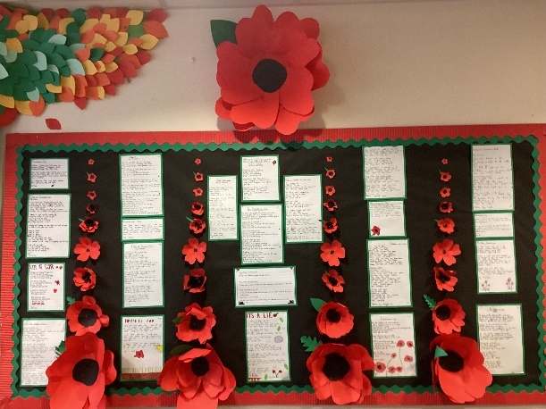

**Year six spent some time today, reflecting on the significance of Remembrance Day. They explored two poems – In Flander’s Fields by John Mc Crae and Dulce Et Decorum Est Pro Patria Mori by Wilfred Owen, who were both enlisted to serve in WW1. They took some inspiration from their war poems to create their own poetry, using a range of poetic devices.**

**Children in Need**



Children in Need will be celebrated on **Friday 18th November 2022**. This year’s theme will be SPOTacular fancy dress. All children are invited to come into school in **fancy dress or wearing spots**. There will be buckets on the gates for donations, or donations can be made via your ParentPay account.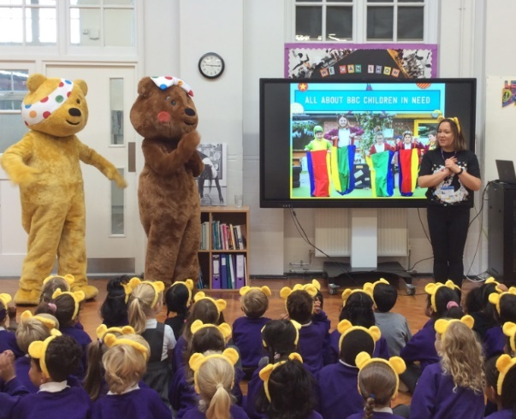

**A big thank you to the Green Team!**

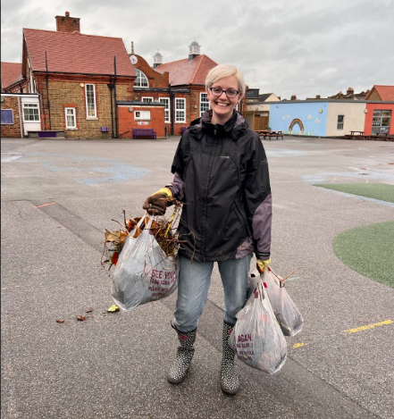

Huge thanks to the Green Team for braving the elements last Saturday and spending the afternoon weeding, litter picking, trimming plants, clearing beds and planting bulbs. Incredible effort from all concerned, both seasoned crew and new members. Look out for beautiful, colourful flowers come Spring. We’re always looking for more volunteers so please do email [friendsoftorridonpta@gmail.com](mailto:friendsoftorridonpta@gmail.com) if you’re interested in getting involved.

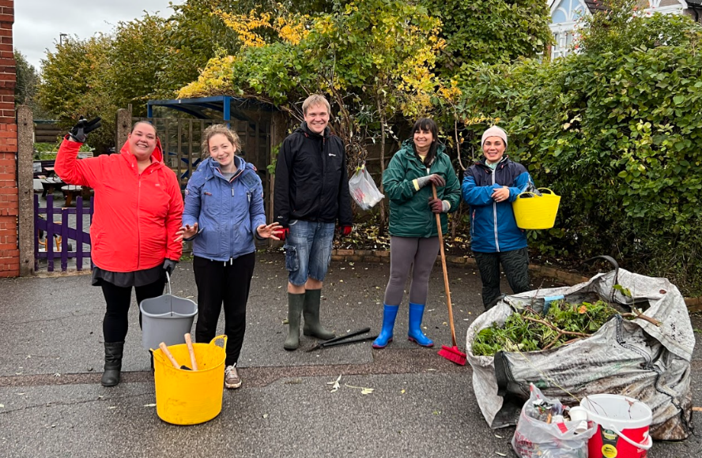

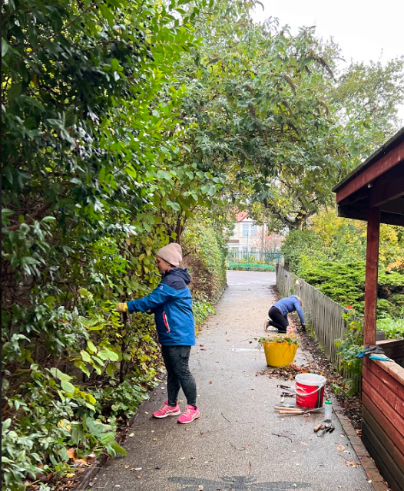

**Rights Respecting School**



**Article 38: Protection in war**

'Governments must not allow children under the age of 15 to take part in war or join the armed forces. Governments must do everything they can to protect and care for children affected by war and armed conflicts.'

This week we have been discussing Article 38 and thought about how it links to Remembrance Day.

We discussed how children are affected by wars and how important it is for them to be protected.

**Dance Partnership with Irie Dance Theatre**

You may remember that we worked with Irie Dance Theatre last as part of the London Borough of Culture celebrations. We are thrilled to announce that Irie Dance Theatre are amongst the organisations successfully joining Arts Council England's National Portfolio in 2023. Success in the funding application will see Torridon become one of their partner schools!  We are proud and delighted to see how this partnership will grow and allow an authentic development of African and Caribbean dance to our curriculum offer.

**Resource Base Trip to Forster Park**

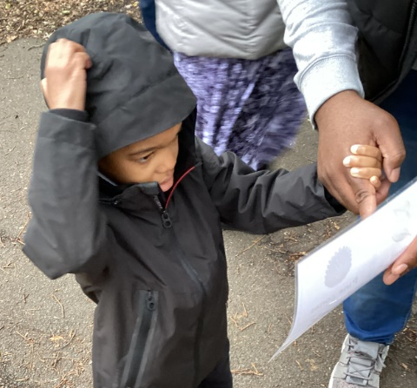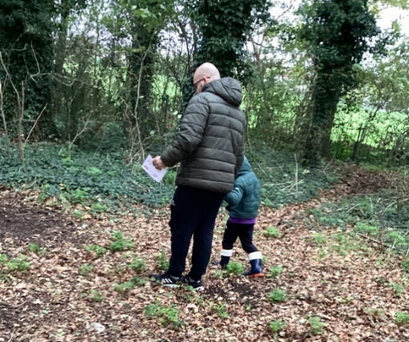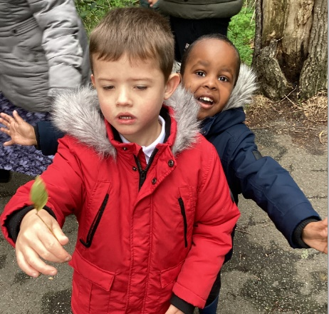We went to Forster Park to go on a leaf hunt! We have been reading the story 'We're going on a leaf hunt' and learning about Autumnal changes. We explored the woods in Forster Park and collected leaves, sticks, pine cones and conkers. The children really enjoyed being out and seeing all of the Autumn leaves.

**Street Trees for Living November 2022 News**



550 new street trees are being planted across the borough this winter! It’s a record number that has climbed steadily since 2012, when just one tree was planted through the council’s sponsorship scheme. To deal with this latest planting challenge, the council's contractor [Street Tree Ltd](https://streettreesforliving.us10.list-manage.com/track/click?u=ab60f4c1dd82f27de2423791e&id=bd9bb4058c&e=662900604e) made an early start this year. In the six weeks since the beginning of October they have planted an amazing 182 residential trees and excavated 231 tree pits.

STfL is growing. They are planting more and more trees every year which is why they are looking for new volunteers. They currently have vacancies for a [Chair of Trustees](https://streettreesforliving.us10.list-manage.com/track/click?u=ab60f4c1dd82f27de2423791e&id=f7cbf09abd&e=662900604e)and [Area Representatives.](https://streettreesforliving.us10.list-manage.com/track/click?u=ab60f4c1dd82f27de2423791e&id=1aafd26e1c&e=662900604e) So if you are interested in trees and the environment and if you would like to help plant more trees in Lewisham, please get in touch.

**School Photographs**

Please remember he deadline for returning photograph orders to the school office is **Friday 18th November.** You can also order online at <https://www.braiswickdirect.co.uk/index.aspx>

**Calling All Reading Volunteers**

At Torridon, we are committed to every child becoming a confident and fluent reader. Now that the world is a little more normal, we are really pleased to be able to welcome parents and carers into school again. If you would like to help out by coming into school to hear children read, please email the admin team with the subject 'Reading Volunteer'. We look forward to hearing from you soon.

**Dates For Your Diary**

|  |  |
| --- | --- |
| **Week beginning 14th November** | Anti-bullying week |
| **Monday 14th November** | Odd Socks Day for anti-bullying week |
| Sports event for Year 2 and Year 3 |
| Year 6 boys to Junior Citizenship Event |
| **Tuesday 15th November** | Resource Base Primary Panathlon CANCELLED |
| **Wednesday 16th November** | Year 6 to Tate Britain |
| **Thursday 17th November** | Year 4 Multiplication Check meeting for parents and carers (5pm) |
| **Friday 18th November** | Children in Need |
| **Monday 21st November** | National Child Measurement Programme |
| **Wednesday 23rd November** | Y3/4 Girls’ Football Tournament |
| Y2 to London Zoo |
| **Thursday 24th November** | Year 4 and Year 5 Fit Media Assessment |
| Year 1 Phonics Screening Check meeting for parents and carers (5pm) |
| **Friday 25th Novermber** | **INSET DAY** |
| **Week beginning 28th November** | Whole school assessment week |
| **Tuesday 29th November** | Y5/6 Girls’ Fotball Tournament |
| **Wednesday 30th November** | Flu Immunisation Programme |
| **Monday 5th December** | Resource Base to Lewisham Bus Garage |
| **Tuesday 6th – Thursday 8th December** | Art Exhibition (Evening Viewing on Wednesday 7th December) |
| **Thursday 8th December** | Resource Base Christmas Assembly |
| PTA Christmas Disco |
| **Monday 12th December** | Year 6 Christmas Assembly |
| **Tuesday 13th December** | Year 4 and Year 5 Christmas Assembly |
| Reception Nativity |
| **Wednesday 14th December** | Nursery Christmas Songs |
| Christmas Jumper Day |
| Christmas Lunch |
| **Thursday 15th December** | Year 1 and Year 2 Christmas Assembly |
| **Friday 16th December** | Last Day of Term (2pm Finish) |
| **Tuesday 3rd January** | **FIRST DAY OF THE SPRING TERM** |
| **Friday 20th January** | **INSET DAY** |
| **Monday 13th – Friday 17th February** | **HALF TERM HOLIDAY** |

**Visit from Chips**

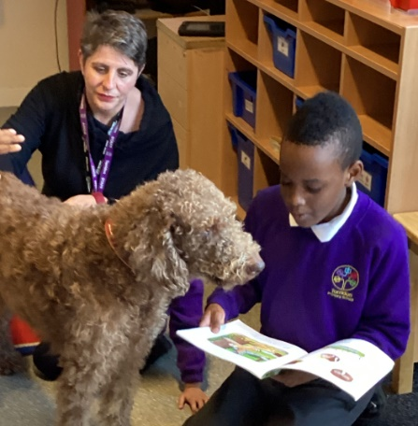**This week, the children in the Resource Base had their very first visit from Chips. Chips is a specially trained therapy dog who helps children to feel calm and happy. The children enjoyed singing to her and reading her stories. We hope she will be back to visit us very soon.**

**Christmas Events**

There are lots of festive fun times ahead before the end of term. Please put the dates in your diary. Further details will follow nearer the time.

Please speak to a member of staff of you have any questions.

|  |  |
| --- | --- |
| **Nursery Christmas Songs** | |
| **Wednesday 14th December** | **9.00am (Morning and Full Time Nursery)** |
| **Wednesday 14th December** | **2.30pm (Afternoon and Full Time Nursery)** |

|  |  |
| --- | --- |
| **Reception Nativity** | |
| **Tuesday 13th December** | **9.00am**  **or**  **2.30pm** |

|  |  |  |
| --- | --- | --- |
| **Christmas Assemblies** | | |
| **Year 1** | **Thursday 15th December** | **9.00am** |
| **Year 2** | **Thursday 15th December** | **2.30pm** |
| **Year 3** | **Wednesday 14th December** | **9.00am** |
| **Year 4** | **Tuesday 13th December** | **2.30pm** |
| **Year 5** | **Tuesday 13th December** | **9.00am** |
| **Year 6** | **Monday 12th December** | **2.30pm** |
| **Resource Base** | **Thursday 8th December** | **9.00am** |

**PTA Christmas Disco**

**Thursday 8th December**

**Christmas Jumper Day**

Wednesday 14th December



**Christmas Lunch**

**Wednesday 14th December**

**Last Day of Term**

**2pm Friday 16th December**

**Nursery Sensory Hut**

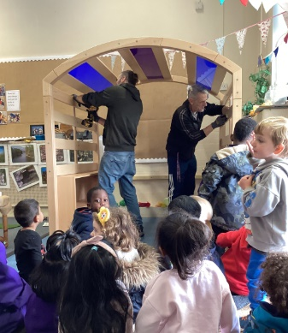

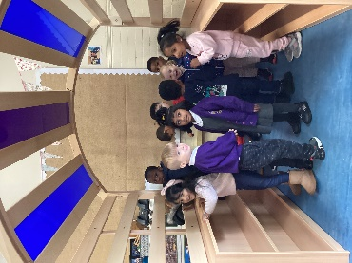Thank you Tom and Darryl for working so hard to build our new sensory hut in the Nursery.

We had such fun dancing inside when you had finished.

**Year 4 Art**

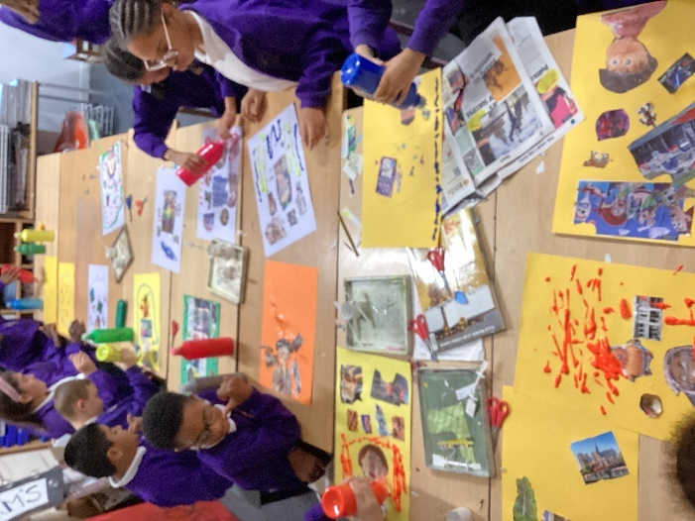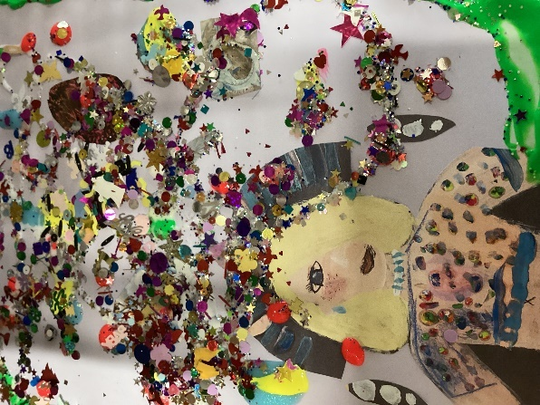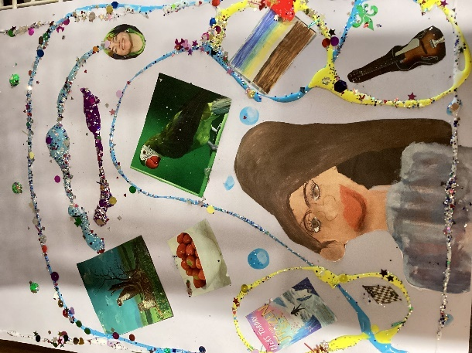Some of Year 4 completed their Chila Kumari Burman inspired pieces this week. They were working on improving their cutting skills and manipulating paint in unusual ways. She likes to use lots of found treasures in her work so we were delighted to find a really old pot of glittery objects in the back of the Art cupboard to adorn the work. These pieces will all be on display in the Whole School Art Exhibition later t his term.



**Stars of the Week**

*Week commencing 26.09.22*

|  |  |  |
| --- | --- | --- |
| **Class** | **Name** | **Reason** |
| Nursery FT | Saint | For his growth in confidence and for his amazing drawing and painting. Well done, Saint! |
| Nursery AM | Tabitha | For her growth in confidence and for her amazing dancing in dance. Well done, Tabitha! |
| Red Class | Mateo | For sounding out all the phonics sounds perfectly. Excellent Mateo! |
| Blue Class | Chance | For good listening and trying his best. |
| Yellow Class | Lula | For being a role model to others and always being kind. Well done! |
| 1G | Kaiyon | His new excellent attitude to learning. He is trying his best in all areas of his learning and is making fantastic progress! Well done |
| 1M | Aamarah | For consistently trying her best and making lots of progress in her maths learning. Well done, Aamarah! |
| 1N | Alfie | For his exemplary behaviour and self-motivation. He always does his best and is a kind friend to his classmates. 😊 |
| 2G | Fatima | For her kindness towards her peers and for using her manners. |
| 2S | Junior | For his positive, friendly manner around the classroom-it is a pleasure to have you as part of 2S! Well done for being such a wonderful role model 😊 |
| 2SW | Sophia | For putting in a lot of effort into her writing and showing great determination! Well done Sophia! |
| 3A | Amelie | For always being kind, respectful and helpful towards everyone in our community including herself and her own learning. |
| 3L | Levi | For showing excellent listening, contributing more in class and participating in home learning tasks! |
| 3S | May | Always being respectful to everyone in our school community. |
| 4C | Arun | Arun is always on task, very respectful and an excellent role model. Keep it up! |
| 4V | Niromika | For being an amazing role model and always showing respect to everyone. Well done. |
| 4W | Joshua | He is a respectful and kind member of the class. He worked especially hard on producing a fantastic diary entry this week. Well done! |
| 5L | Lashvin | For consistently being respectful and showing great improvement within his writing. He has used a great array of persuasive features and vocabulary. Well done! |
| 5R | Arda | For excellent effort in his learning and contributing more to class discussions. Well done, keep it up! |
| 5S | Hazel | For her excellent piece in writing, for your great use of vocabulary and persuasive language. For always contributing to class discussion. Well done! |
| 6A | Felicia | For not only being a respectful member of our school community, but also an excellent role model who is always committed to her learning. |
| 6C | Sanjana | For always being respectful to others and being an excellent role model  – well done! |
| 6L | Yoel | For really focusing during writing and producing an excellent diary entry – well done! |
| Blue Pathway | Kenny | Well done for showing resilience and flexibility this week. |
| Green Pathway | Amarachukwu | Well done for continuing to integrate so well into your Year 1. Class. Keep it up! |

**Early Years SEND FACTOR**

|  |  |
| --- | --- |
| **Session date and time** | **Session summary** |
| |  | | --- | | Thursday 8th December  10.00-11.00 | | |  | | --- | | Introducing **Lewisham’s Resource Bases**.  The Early Years Lead/Resource Base Leads give an overview of their Base and how it works in a mainstream school. | |
| |  | | --- | | Thursday 12th January  10.00-11.00 | | |  | | --- | | **Supporting children with social communication differences.**  Introducing Lewisham Autism Support and Drumbeat ASD Outreach Support Teams advising on what they do and how they can support your child. | |
| |  | | --- | | Thursday 9th February  10.00-11.00 | | |  | | --- | | Introducing the **Speech and Language Therapy Service.**  A specialist speech and language therapist will be sharing an overview of their service and how they may support your child. | |
| Thursday 9th March  10.00-11.00 | |  | | --- | | **Getting help and support.**  For this session we will be joined by SENDIASS & Parent Carer Forum as well as other organisations that can offer information, advice and support. | |
| |  | | --- | | Thursday 13th April  10.00-11.00 | | |  | | --- | | The **Health Visiting Team** share their top tips on toilet training and we talk about how you can get more help for your child if needed, as they get older. | |
| |  | | --- | | Thursday 11th May  10.00-11.00 | | |  | | --- | | The **Early Years Quality & Inclusion Team** share their transition timeline and talk about the work they do with schools and nurseries to support transition into school for children with SEND. | |
| |  | | --- | | Thursday 8th June  10.00-11.00 | | |  | | --- | | A mainstream school SENCO joins us for this session to talk about what SEN support looks like in a primary school. | |
| |  | | --- | | Thursday 13th July  10.00-11.00 | | |  | | --- | | **Share your views** on what you have found helpful, how you think we could improve and what you may like to see in future sessions.  We are also happy to have a general chat and answer any queries you may have. | |

