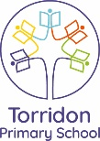 RB Ana and Lena Home Learning: Autumn 2
This half term, our topic will be ‘Pirates.’ We will be focusing our learning around the stories ‘The pirate next door”‘ We would like you to complete at least two of the items listed in column 1 and then to choose some, or all, of the tasks in column 2. All designing and written tasks can be completed in the children’s home learning book.
Column 1 | Column 2
Suitcase must haves!  If you were going on a pirate seaside adventure, what would you pack in your suitcase and why?  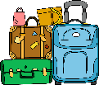  Draw and label what you would take with you and tell us why you have chosen those items. Don’t forget to use finger spaces, capital letters and full stops in your writing. | Make your own diorama:  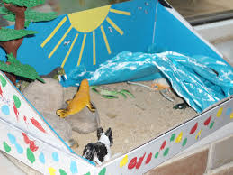  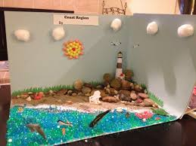  Can you create a 3D model of the seaside? Dioramas are a great way to create a wonderful setting so get creative!
Can you make a tally chart?  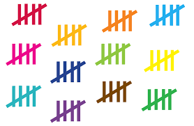  Make a tally chart and ask the people you know whether they recycle or not. You may want to add more categories by including if they recyle paper, plastic or food etc. | Reusable shopping bags:  Design your own reusable shopping bag to encourage people not to waste plastic bags.  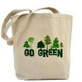  What material would you use for your bag? Think about which material would be most suitable and why…Metal? Glass? Wood? Plastic? Foil? Etc
Can you research an island?  Have a go at writing a fact file about your chosen island. Where would the treasure be? Try to draw the island and put an X where you think the gold will be.  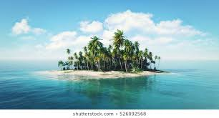 | Can you make a ‘Save our Oceans’ poster?  Have a go at drawing/creating an underwater scene. You could even try and make it 3D and include some pop-up facts to encourage people to save our oceans and ensure they recycle.  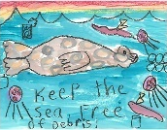

Bring in your completed projects by: Monday 14th December 2020.

