Year 1 Home Learning - Writing w.c. 21.09.2020
English: Writing
Learning linked to theme of ‘Looking After Ourselves and Each Other’
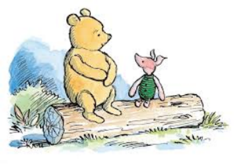 | Describing Appearance  Watch the story of ‘Winnie the Pooh’ https://www.youtube.com/watch?v=OpIT3t3_t7A  Use key words to describe what Winnie the Pooh and some of the characters look like. These description words are called ‘adjectives’. Have a go at describing what your favourite character looks like. If you gave your description to someone else in your house, could they guess which character it is based on what you have said they look like?
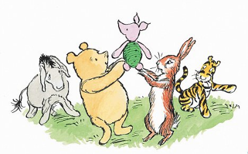 | Describing a Character  Watch the story of ‘Winnie the Pooh’ https://www.youtube.com/watch?v=HwCewzY9OU4&list=PLfUu_fGMSSot5HwWQhpyaZDsZEz3Xw6Em  Winne the Pooh and friends all have their own thoughts and feelings. Look at all the pictures of Winne the Pooh in the video clip and have a go at writing one or two sentences to describe your favourite character from the story.
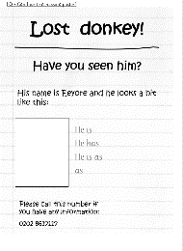 | MISSING!  Oh no! Eeyore is missing. Everyone in the Hundred Acre Wood have been hunting for him. Have a go at creating a ‘MISSING@’ poster to help find Eeyore.  Have a go at including at least one question on your MISSING poster – remember, a question needs a question mark at the end!  Let’s hope Eeyore returns soon.
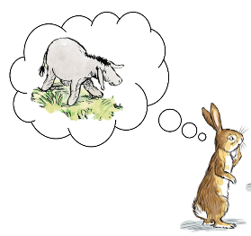 | Dear Eeyore…  Eeyore has finally been found; he is at home but doesn’t want to come out into our wonderful world. He needs your help! Write Eeyore a letter telling him how marvellous our world is and what he will be missing if he never comes out. Remember to use your adjectives and don’t forget to sign the letter from you!
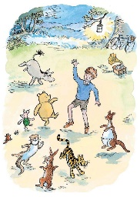 | Interview Time:  The animals of Hundred Acre Wood need you! Eeyore loved your letters and has finally come out - everyone is so happy!  You have the opportunity to speak to Eeyore and ask him all about when he went missing. Write down some questions for that you’d like to ask Eeyore… don’t forget your question mark (?) at the end of your questions.

Year 1 Home Learning - Phonics w.c.21.09.2020
 | English: Phonics
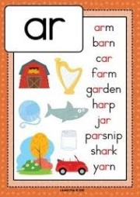 | Let’s remind ourselves about the ‘ar’ digraph:  When you see the digraph ‘ar’, it usually makes the following sound: https://www.youtube.com/watch?v=QXBQDsgRuMo  Go to www.phonicsplay.co.uk and play a game of Dragon’s Den > phase 3 > ‘ar’. Make a list of all the real and alien words.  Choose at least three of the real ‘ar’ words and write sentences for them.
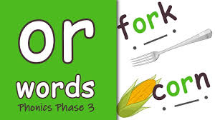 | Let’s remind ourselves about the ‘or’ digraph:  When you see the digraph ‘or’, it usually makes the following sound: https://www.youtube.com/watch?v=Fm9PRHDJlv4  Go to www.phonicsplay.co.uk and play a game of Dragon’s Den > phase 3 > ‘or’. Make a list of all the real and alien words.  Choose at least three of the real ‘or’ words and write sentences for them.
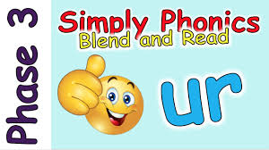 | Let’s remind ourselves about the ‘ur’ digraph:  When you see the digraph ‘ur’, it usually makes the following sound: https://www.youtube.com/watch?v=0uVVJXbc870  Go to www.phonicsplay.co.uk and play a game of Dragon’s Den > phase 3 > ‘ur’. Make a list of all the real and alien words.  Choose at least three of the real ‘ur’ words and write sentences for them.
Let’s remind ourselves about the ‘ow’ digraph:
When you see the digraph ‘ow’, it usually makes the following sound: https://www.youtube.com/watch?v=GJtvjxBYg7I
Go to www.phonicsplay.co.uk and play a game of Dragon’s Den > phase 3 > ‘ow’. Make a list of all the real and alien words.
Choose at least three of the real ‘ow’ words and write sentences for them.

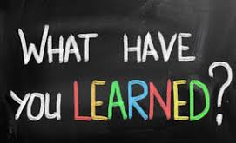 | Let’s review all 4 digraphs from this week:  Go to: https://www.ictgames.com/mobilePage/bingo/index.html and click on Phase 3. Select the 4 digraphs from this week.  Play a game of bingo against someone else in your house – who won?  Choose at least two of your bingo words and write sentences for them.

Year 1 Home Learning – Maths, Science and Topic w.c. 21.09.2020
Maths | White Rose Maths: Scroll down the home page and go to the block marked Autumn Term: Number Place Value (Within 10) Please complete the first five sessions this week.  https://resources.whiterosemaths.com/resources/year-1/
Science  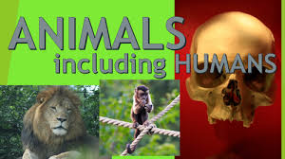 | Animals Including Humans  This is our topic for this term. Write down everything you can think of about animals, including us as human beings using the sheet we’v uploaded. It can be anything you can think of and you can add it to it as you think of new things. Make sure you keep it safe because we’ll be coming back to look at what everyone has written towards the end of this half term.
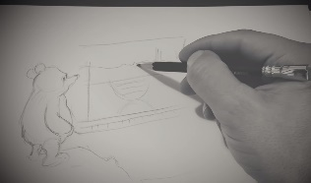 | Art and Design:  We do love to sketch. Watch this video which shows you techniques of sketching and have a go yourself: https://www.youtube.com/watch?v=FmW90X2-WLY  Which character will you choose to sketch?
P.E. | Multiskills:  Watch this video and have a go at joining in, either inside or out. If you haven’t got the markers he’s using, use other household objects instead to be the markers. Enjoy the exercise! https://www.youtube.com/watch?v=AJb_-d0DrgA&feature=youtu.be&t=1
Well-being / PSHE | .  Listen to Me Box:  Having a go at making your every own ‘Listen to Me’ box. This is a box, where you can write any feelings you may be having, for example, happy, worried, excited, sad and so on. they have. These feelings can be about anything you like including home, friendship or school and your box can be made from anything you like, for example, a shoe box, cereal box or even an amazon box! At the end of the day or week, as a family you can have a look at what you have written together and talk about your feelings. Perhaps your family would like to post in the box too and you can have a family discussion about how you are all feeling.
Every day activities | Reading, phonics / spelling, times tables, number bonds  KS1: Phonics and spelling - https://www.bbc.co.uk/bitesize/subjects/zgkw2hv  Maths - https://www.bbc.co.uk/bitesize/subjects/zjxhfg8

Year 1 Home Learning – |Spelling w.c. 21.09.2020
Look, Cover, Write, Check.
Words: | Write… then check | Write… then check | Write… then check
will
that
then
now
she
this
with
them
they
are

