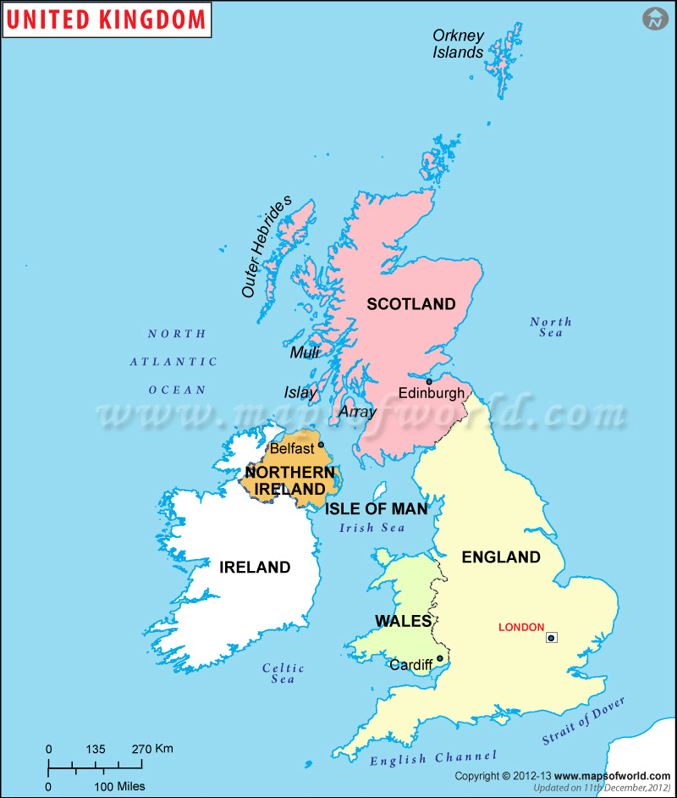

**Capital Cities**

Edinburgh

London

Cardiff

Belfast

**United Kingdom**

Write a sentence about two of the capital cities or countries.

1. _________________________________________________________________________________________________________________________________________________________________________________________________________
2. _________________________________________________________________________________________________________________________________________________________________________________________________________

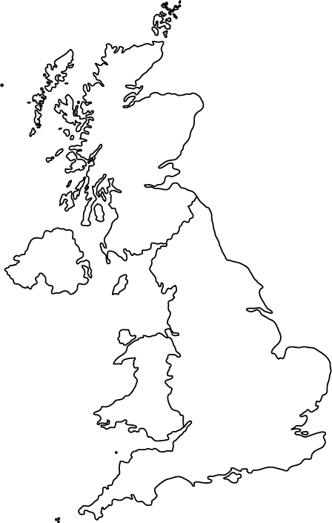

**Northern Ireland**

**Wales**

**Scotland**

**England**