Year Three Science Lesson Resource

Blossoming Beans

Step 1: Write a short description of what plant germination means.

Step 2: Experiment!

Materials needed:
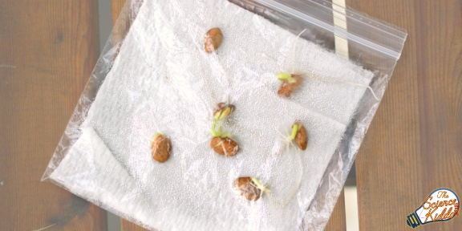
- 2s (dry) kidney beans. Any dry beans will work (pinto, black, lentil)
- 2 Ziplock plastic bag
- 2 paper towels
- Spray bottle filled with water

Instructions:
- Dampen the paper towels with the spray bottle.
- Place the wet towels into two separate Ziplock bags.
- Place each bean on top of the wet paper towels and seal the bags shut.
- Place one of the Ziplock bags in a warm, sunny place and the other in a cool, dark place.
- Keep an eye on your beans throughout the week and add water to the paper towels when they dry out using your spray bottle.
- Measure your bean plant’s growth each day using a ruler and record each plants measurement using the table below.
- Observe both plants and see how they grow. You will need to be patient, as this can take up to 5-7 days! You can even watch them grow over two weeks!
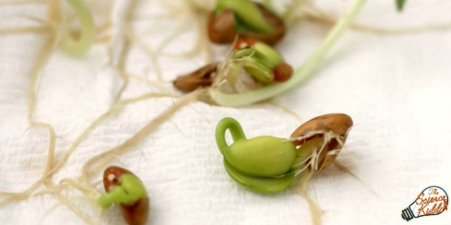

Step 3: Write a conclusion

Describe what you learned and consider the following questions:

What did you notice about the bean growing in the warm sunny place?
What did you notice about the bean growing in the cool, dark place?
What did this tell you about what plants need in order to germinate successfully?
Did you learn anything new, or unexpected from your experiment?
Days | Warm, sunny bean measurements (mm) | Cool Dark bean measurements (mm) | Observation notes (what do you notice?)
Monday
Tuesday
Wednesday
Thursday
Friday
Saturday
Sunday

