Year Three Reading Lessons 3 and 4
City Jungle

Rain splinters town.

Lizard cars cruise by;
Their radiators grin.

Thin headlights stare -
shop doorways keep their mouths shut.

At the roadside
Hunched houses cough.

Newspapers shuffle by,
hands in their pockets.
The gutter gargles.

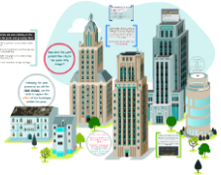
A motorbike snarls;
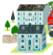
Dustbins flinch.

Streetlights bare
Their yellow teeth
The motorway’s
cat-black tongue
lashes across
the glistening back
of the tarmac night

Pie Corbett

