Year Five Writing Lesson 2
Onomatopoeia is a word which sounds like what it describes.
Task: Unscramble these onomatopoeic words.
Now write some sentences containing some of the words you have unscrambled. You can use different forms of the root word by adding ing, ed, s or es.
_________________________________________________________________________________
_________________________________________________________________________________
_________________________________________________________________________________
_________________________________________________________________________________
Alliteration is when words that are close to each other begin with the same letter (etc., t, p) or sound (etc., st)
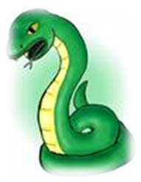
The Slippery Slimy Squirmy Snake

Effective because:
The mood of something can often be enhanced. The repeated use of the letter ‘s’ is suggestive of the hissing sound that a snake makes. Similarly, the alliteration echoes the graceful movement of a snake, as each word seamlessly slides into the next!
Task: Have a go at writing your own examples of alliteration using the following words:

_______________________________________________________________________ Sun
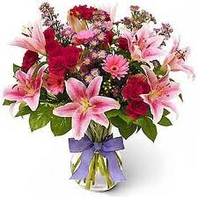
__________________________________________________________________________ Flower

__________________________________________________________________________ lollipop

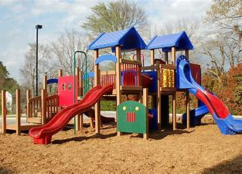
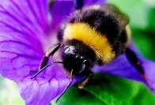
_______________________________________________________________________ playground

_______________________________________________________________________ bumblebee

