Ana Green Pathway Home Learning - English w.c. 6.07.2020
 | English: ‘Summer in the city’.
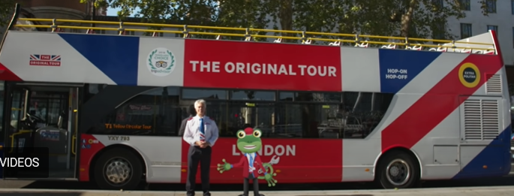 | London Bus tour!  Let’s take a guided tour on a bus through London!  We are going to see lots of famous buildings, have you been to any of those places?  https://youtu.be/w8zF6tnhaTU  We are going to be learning about all of them this week. We will also be making lots of crafts related to those landmarks  How many people will go on the tour bus? Think about it. You can play this game Resources: Bus addition and subtraction to 10.  CHALLENGE YOURSELF: In what order are we going to visit the famous places? Think about 1st, 2nd, 3rd, 4th,… last.
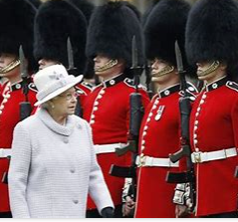 | Buckingham palace : 1st stop  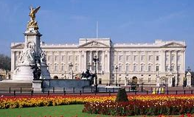  Have you ever seen the Change of Guards at Buckingham Palace? Watch this video https://youtu.be/1-s26lBcu_M It is very famous all around the world!  Describe what you see and role play how the Guards march.  CHALLENGE YOURSELF: If you went to London to see the Queen what would you take on your journey?  How would you travel? Bus, Train, Car…? Share your ideas with an adult.
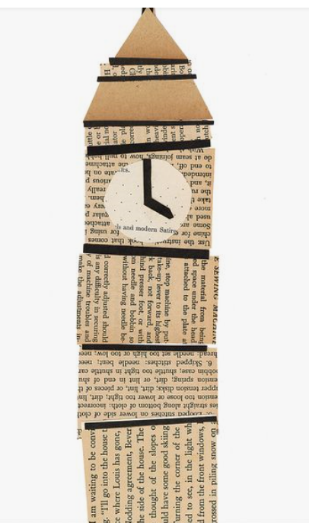 | Big Ben: 2nd stop!  Listen to the famous clock tower, how many dongs can you hear? https://youtu.be/E9wWBjnaEck  You can find more videos about the Big Ben. Have also look at the craft on the left side, could you make a Big Ben out of news paper?  CHALLENGE YOURSELF: What’s the time Mr Ben? Try to complete the Resource: Write the time o’clock cards and do the same number of dongs.
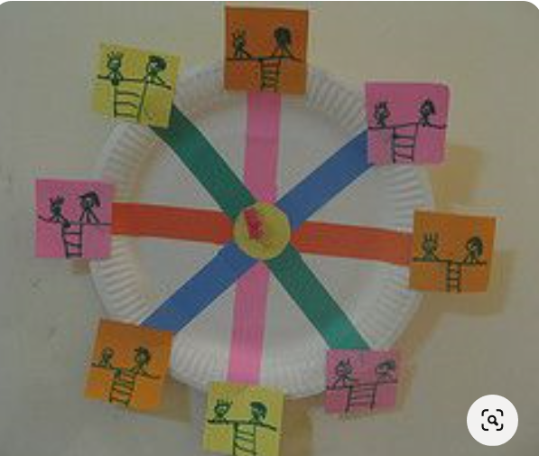 | London eye: 3rd stop!  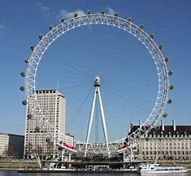  I would like you to look a pictures of the London eye. What shapes can you see? Try to make the craft displayed on the left, you will only need a circle and to cut strips of paper and squares to make the carriages. Don’t forget to draw the people having fun!  CHALLENGE YOURSELF: Have a look at Paddington and his aunty visiting London , what do they see? https://www.youtube.com/watch?v=tr9uAwA-APM
4th stop!  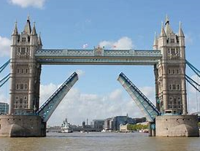 | Music time!  Do you remember our Cbeebies morning songs?  Everybody smiling now https://www.bbc.co.uk/iplayer/episode/p06r1y07/sing-with-cbeebies-series-1-12-everybodys-smiling-now  Like a lizard https://www.bbc.co.uk/iplayer/episode/p06r20p4/sing-with-cbeebies-series-1-13-like-a-lizard  Wave https://www.bbc.co.uk/iplayer/episode/p06r1ybf/sing-with-cbeebies-series-1-14-wave-wave-wave  CHALLENGE YOURSELF: Dance to the rhythm of Tower Bridge opening and close! https://youtu.be/K37GBid8_6Y
Ana Green Pathway Home Learning - Writing w.c.6.07.20
 | Learning linked to theme of ‘Summer in the city’.
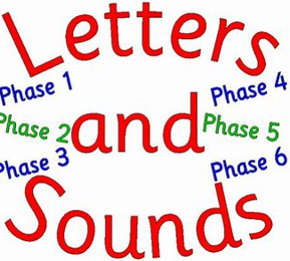 | New sound to practise  This week we are going to focus on the sound ee: teeth, bee , feel, feet.  Have a look at this video https://youtu.be/du3incCU6Xc  You can also practice ee sound by playing this game: https://www.phonicsplay.co.uk/resources/phase/2/buried-treasure +ee  CHALLENGE YOURSELF: Complete ee cut and paste sound worksheet
Tower of London  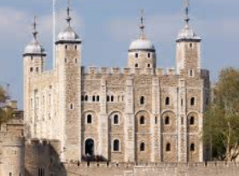 | Tower of London 5th stop!  Have you ever been to the Tower of London? Have a look at this video which tells you what kind of things you would expect if you go in https://youtu.be/npm6UuWMBVE  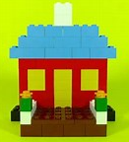  Try to make a Castle using Lego or Duplo  CHALLENGE YOURSELF: Can you make a Castle out of 2D shapes? Resource: 2d shapes castle pictures.
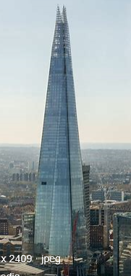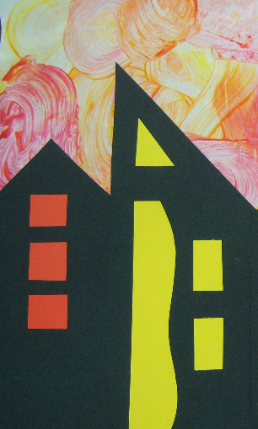 | Finger gym : The Shard 6th stop!  Remember to keep on practicing our finger gym as a warm up https://www.youtube.com/watch?v=3VpARNgbb8c  Have a look at Shard building at night https://youtu.be/2a_qmDythbk  Beautiful, right? Why don’t you try to make a really tall building using card? Any paper would also do, you just need to cut out lots of different windows to stick on it! Did you know the Shard is made of 11,00 glass panels!  CHALLENGE YOURSELF: Find out which train station you will have to go to visit The Shard.
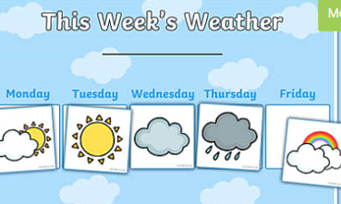 | Weather book  Before we plan our day we need to check what the weather is going to be like!  I normally check the weather on the following website https://www.bbc.co.uk/weather/2644556  This week I would like you to complete the weather record worksheet, drawing the symbols on each box.  CHALLENGE YOURSELF: Watch the news weather then use this Resource: United Kingdom Weather Forecasting Role Play Pack and be your family weather forecast expert!
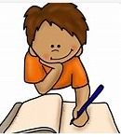 | Writing time  I would like you to play this game. http://www.ictgames.com/mobilePage/skyWriter/index.html Please follow the letter shape on the screen with your finger.  Then complete Resource: curly caterpillar letters  CHALLENGE YOURSELF: Please recap again all sounds learnt so far https://youtu.be/DIpcahxNSU4 https://youtu.be/vU2vWZKS7rY and then write cvc words using pens, chalk, paint brushes, finger painting..
Ana Home Learning – Maths, Science and Topic w.c. 29.06.2020
Maths: time | - Recap O’clock time with this video https://youtu.be/EIxaxnageTo then play https://www.sheppardsoftware.com/mathgames/earlymath/on_time_game1.htm  - We are going to learn about Half past times this week https://youtu.be/QWMMVC5AyeU Resource: Half past time matching cards.  - Half past game https://www.turacogames.com/games/telling-time-space-math-game-for-kids/ Resource: half past bingo  - Digital time https://youtu.be/ENOYemdWU08 Resource: matching analogue and digital oclock.  - Talk to your adults about the difference between 1 second, 1 minute, 1 hour. You can then sort this cards Resource: second, minute, hour sorting  CHALLENGE YOURSELF: Play “What’s the time Mr Wolf?” explain your family how to play the game!
Practical Maths Activity  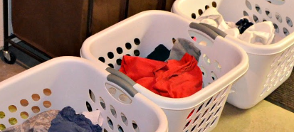 | Sorting objects at home  - Do the laundry together. Sorting clothes in different colours or types (e.g. shirts, trousers) will develop listening and concentration on shape, colour, patterns… Pairing socks will work on the understanding of shape matching, try counting in twos.  Set the table for the family. Talk about how many forks, spoons, cups, etc. you need, and count out the right amount.
Science  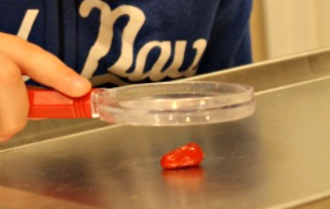 | Are seeds the same?  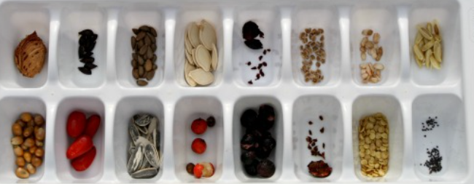  Collect different seeds, observe and record different features of different seeds: size, colour, weight. Maybe adults can help you cut the seeds open and compare the inside structure of the seed. This is a great exercise to learn observation comparison and differentiation.  CHALLENGE YOURSELF: Plant a few seeds following the sequence. Resource Fruit plant growing sequence
Mindfulness | Balloons  Playing with balloons. Tell your kids that the aim of this game is to keep the balloon off the ground, but have them move slowly and gently. You can tell them to pretend the balloon is very fragile if that helps.
Speech and Language  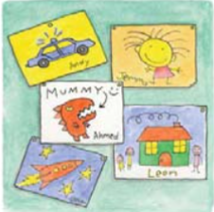 | Play: Puzzles  Do a simple jigsaw puzzle with your child. If you don’t have any puzzles, you can make your own by cutting up a picture from a magazine into 4 to 6 pieces – can your child put them back together to make the picture?
Everyday activities | Reading, phonics / spelling, times tables, number bonds  KS1: Phonics and spelling - https://www.bbc.co.uk/bitesize/subjects/zgkw2hv maths - https://www.bbc.co.uk/bitesize/subjects/zjxhfg8
Dates to research this week
(Creative arts activities are on a separate sheet).

