Ana Green Pathway Home Learning - English w.c. 13.07.2020
 | English: ‘Transition’.
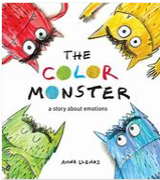 | The colour monster story  https://youtu.be/Ih0iu80u04Y  Colour in each monster with different emotion colours and one like a rainbow, do you remember what colour was for each emotion? Resource: Monster colouring sheets  CHALLENGE YOURSELF: Role play the different emotions. Use a mirror to see how your facial expression can change to show emotions.
Things that make me happy
“Because I’m happy” by Pharrell Williams: https://youtu.be/8SRp2ZCHHpA
How does this song make you feel?
Think about all the things that make you happy. Resource: what makes me happy
CHALLENGE YOURSELF: Think about what makes mum, dad, sister, brother… happy. You can complete the same resource with them. What makes you happy about school?
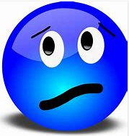 | Things that make me sad  Everybody feels sad sometimes, it is ok to feel that way  Watch: When I am feeling sad https://youtu.be/Z1w5bs9mZ2Y  Have a look at different pictures on internet, photographs, magazines, and see if they feel sad or not, why do you think they feel that way?  You have probably watched Frozen, how is Elsa feeling in this video? https://youtu.be/L0MK7qz13bU  Resource: Are they sad  CHALLENGE YOURSELF: Can you find (or compose) some music that is ‘sad’? Is it something you would like to change in school?
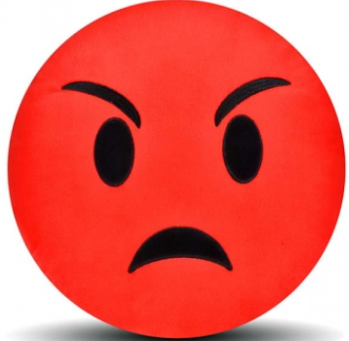 | Things that make me angry  Listen to Ravi’s Roar story : https://www.youtube.com/watch?v=u2vCgAlSO84  Why is Ravi feeling angry?  Discuss with an adult a time when you have become very angry. What do you do? How can you mange you anger?  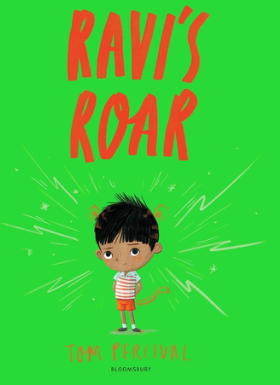  CHALLENGE YOURSELF: Resource: When I am angry I can…
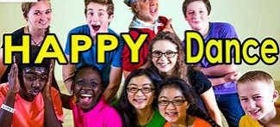 | Music time!  Happy Dance https://youtu.be/cQ6BPWyIueQ  Can’t stop the feeling https://youtu.be/KhfkYzUwYFk Go Noodle!  Feelings song https://youtu.be/utZr0dPu5sk Try to pull all the faces you see in this song  CHALLENGE YOURSELF: How does music make you feel? Think of different songs/styles of music that make you happy, sad, angry etc.
Ana Green Pathway Home Learning - Writing w.c.13.07.20
 | Learning linked to theme of ‘Transition’.
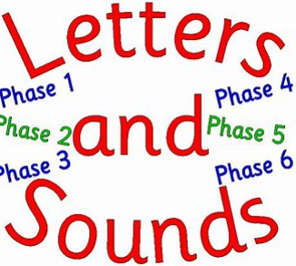 | New sound to practise  This week we are going to focus on the sound igh : high, night.  Have a look at this video https://youtu.be/3UVtOaeBIDg  You can also practice ai sound by playing this game: https://www.phonicsplay.co.uk/resources/phase/2/buried-treasure +igh  CHALLENGE YOURSELF: Complete igh workbook
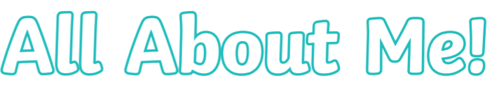 | Transition  How do you feel about going back to school?  We will all be a bit nervous when we come back. You can complete All about me booklet so your new teacher will know a bit more about you!  Resource: All about me booklet  CHALLENGE YOURSELF: I like, I don’t like resource
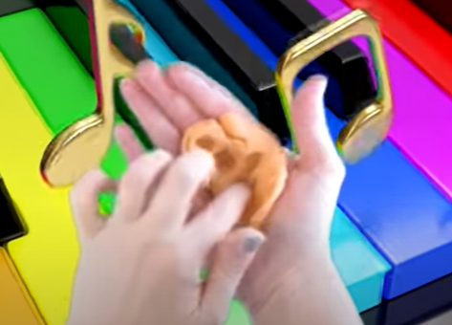 | Finger gym  Try this new finger gym as a warm up https://youtu.be/DrBsNhwxzgc  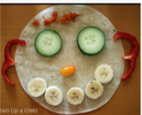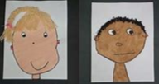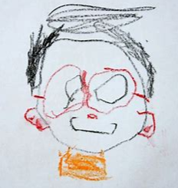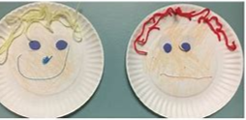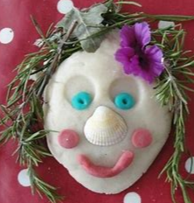  CHALLENGE YOURSELF: Make a lovely self-portrait, use any materials, tools you want!
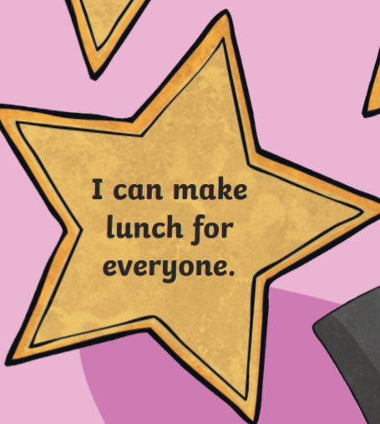 | Being positive  We have all spent more time at home with our families during the past few months, and it might have been challenging to not be able to see your friends, other members of your family or being in school!. This week I would like you to think positively. During this difficult time, you may have learnt new skills, discovered new talents and found more of your special qualities. Those we need to celebrate! Do feel free to add other things that you have enjoyed in the last few months too (e.g. spending more time with your family, having more time to read books or watch films). It's important to celebrate the good things in life. Do not forget to share those with your new teacher!  CHALLENGE YOURSELF: Complete Resource: Positives from lockdown Cut out the stars and make a nice poster.
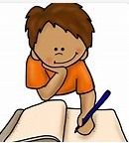 | Writing time  I would like you to play this game http://www.ictgames.co.uk/literacy.html Please listen carefully to the word and choose the right sounds to make it.  Then complete Resource: 10 to 20 number formation  CHALLENGE YOURSELF: Please recap again all sounds learnt so far https://youtu.be/DIpcahxNSU4 https://youtu.be/vU2vWZKS7rY and then write cvc words using pens, chalk, paint brushes, finger painting..
Ana Home Learning – Maths, Science and Topic w.c. 13.07.2020
Maths: time  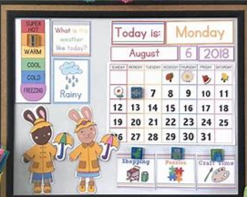 | This week we are going to talk about the calendar.  - First, I need to you recap the days of the week and numbers 1 to 30. https://youtu.be/mXMofxtDPUQ https://youtu.be/lndiN1TO0I8 Resource: days of the week cut and stick.  - Then we need to recap the months of the year https://youtu.be/Fe9bnYRzFvk Resource: months and seasons cut and stick  - I would like you to look at a calendar at home today. Check if it has all the months of the years and how many days in each month. You will also see that you have the days of the week on the calendar. You can also look at this calendar minicalendar 2020.  - Locate information on the calendar. What day is it today? What day will it be tomorrow? Look at the numbers and the day of the week. How many days until the end of July? Ask all the members of your family when their birthday is, then find it on the calendar.  - Tuesday 21st of July is officially the last day of “school”. How many days until we get there? School will come back again in September, can you check how many days do we have in August? Can you cross out one day each day in the calendar during the holidays and count how many days until September?  CHALLENGE YOURSELF: Play the months of the year game here https://www.turtlediary.com/game/months-of-the-year.html
Practical Maths Activity  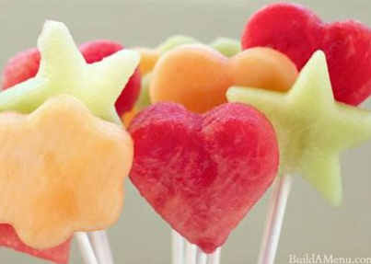 | Sorting objects at home  - Cut vegetables or fruit into different shapes. Make a pattern with different colours or shapes of fruit and vegetables.  - Talk about the daily routine. Point out days on the calendar and times on the clock and use language such as today, tomorrow, yesterday, this morning, now, next, after that and so on. Refer to the days of the week and the idea of weekdays and weekends.
Science  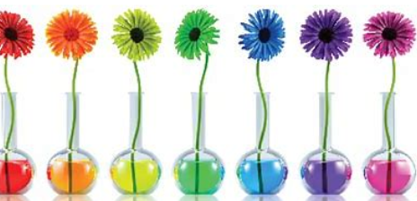 | Colourful vegetables and flowers  Learn how water moves up through plants using food colouring. This activity works particularly quickly with celery, but you could also use white-petalled flowers. Put some celery sticks (preferably with leafy tops) in separate glasses of water, then add different colours to each glass. Within an hour or two the celery will change colour as the dye moves up through capillary action.  CHALLENGE YOURSELF: You can even create a flower that has two colours, half with one colour and half with a different colour. This experiment will show you how water travels to different parts of flowers. Ask your parents to cut the stem for you https://youtu.be/AMvEVnAFCNA
Mindfulness  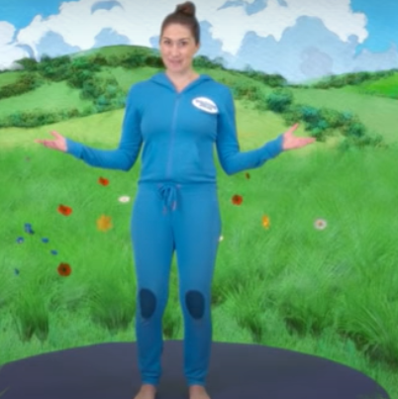 | Cosmic Yoga  We are going on a bear hunt! A cosmic kids yoga adventure!  https://youtu.be/KAT5NiWHFIU
Speech and Language  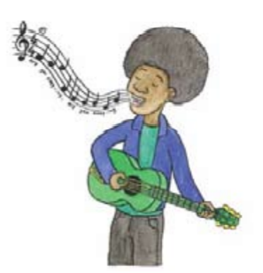 | Listening: Spot the mistake  Sing a simple rhyme or song, but make a mistake – can children spot the mistake? Incy wincy spider climbing up... a tree (should be spout) The wheels on the... train go round and round (should be bus) colour in Twinkle twinkle little... hat (should be star)
Everyday activities | Reading, phonics / spelling, times tables, number bonds  KS1: Phonics and spelling - https://www.bbc.co.uk/bitesize/subjects/zgkw2hv maths - https://www.bbc.co.uk/bitesize/subjects/zjxhfg8
(Creative arts activities are on a separate sheet).

