Year Six Reading Lesson 4
The Tower of London

For over 900 years, the Tower of London has been standing guard over the capital. The Tower of London was originally built by William the Conqueror, following his successful invasion of England in 1066.
The Tower of London is perhaps better known as a prison. The prisoners would be brought, via the river, from Westminster where they would have been tried, and crowds would wait on the riverbank to find out the verdict to see if they would be treated to the spectacle of a public execution. The executioner, with his long sharp axe, would stand behind the accused on the boat. If the accused was guilty, he would point his axe towards the victim, and, if not guilty, he would point it away. People knew that if found guilty there would be a public execution 48 hours later.
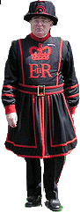
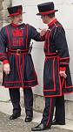
The responsibility for looking after the prisoners was given to the Yeomen Warders or Beefeaters (These guards, although looking very similar, are different from the Yeomen of the Guard).
The name Beefeaters is often thought to come from the French word - 'buffetier'. (Buffetiers were guards in the palace of French kings. They protected the king's food.) However, the name Beefeater is more likely to have originated from the time when the Yeomen Warders at the Tower were paid part of their salary with chunks of beef. This took place right up until the 1800s.
Today, the Tower of London houses the Crown Jewels and is open to the public as a museum.

