Year Five Writing Lesson 1
The City of Madrid
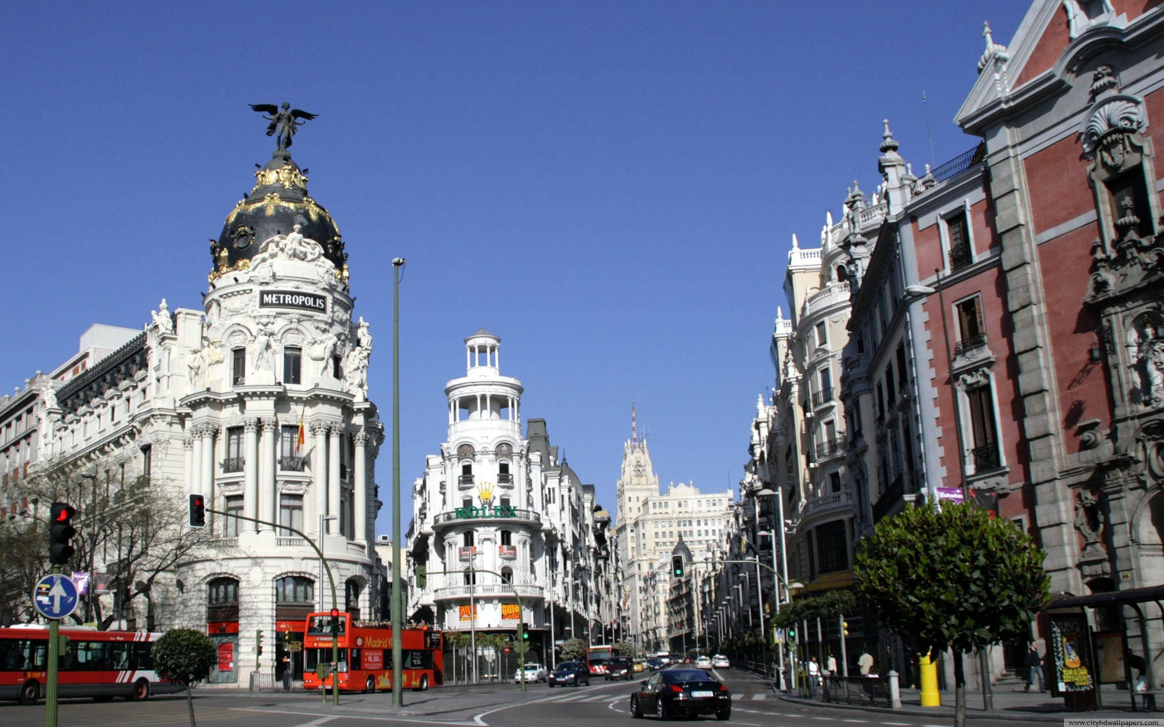
What adjectives would you use to describe this city?

Study the first picture (above) and consider the following questions:
What do you notice about the weather/atmosphere?
How do you think people travel around this city?
Do you notice anything familiar or strange about this city?
Would you like or dislike to live in this city? Think about why.
Fantasy City
What adjectives would you use to describe this city?
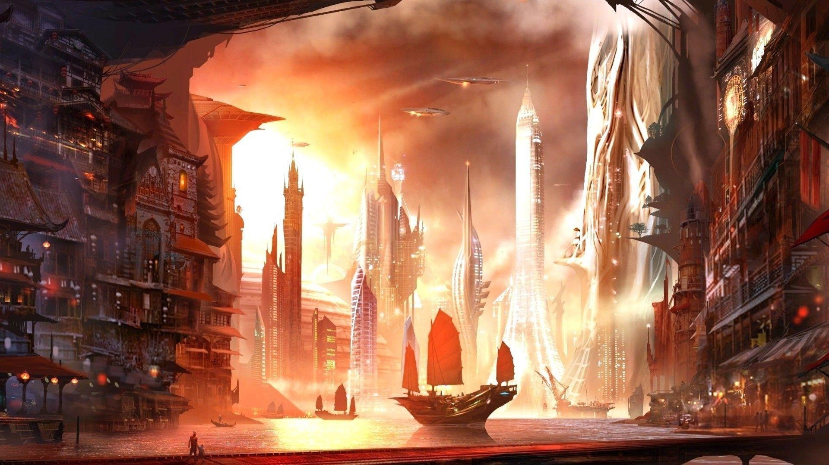
Study the second picture above and consider the following questions:
What do you notice about the weather/atmosphere?
How do you think people travel around this city?
Do you notice anything familiar or strange about this city?
Would you like or dislike to live in this city? Think about why.

