Year Five Reading Lesson Resource

Last Night, I Saw the City Breathing

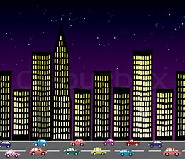

Last night, I saw the City breathing
Great Gusts of people,
Rushing in and
Puffing out
Of Station’s singing mouths

Last night, I saw the City laughing,
Take-Away got the giggles,
Cinemas split their sides,
And Living Rooms creased themselves!

Last night, I saw the City dancing.
Shadows were cheek to cheek with brick walls,
Trains wiggled their hips all over the place,
And the trees
in the breeze,
Put on a show for an audience of windows!

Last night, I saw the city starving,
Snaking Avenue smacked her lips
And swallowed seven roundabouts!
Fat office blocks got stuffed with light
And gloated over empty parking lots.

Last night, I saw the City crying.
Cracked windows poured falling stars
And the streets were paved with mirrors.

Last night, I saw the City sleeping
Roads night-dreamed,
Street Lamps quietly boasted,
‘When I grow up, I’m going to be a star!’
And the Wind,
Like a cat,
Snoozed in the nooks of roofs.

By Andrew Fusek Peter

