**Year Four Geography Resource**

[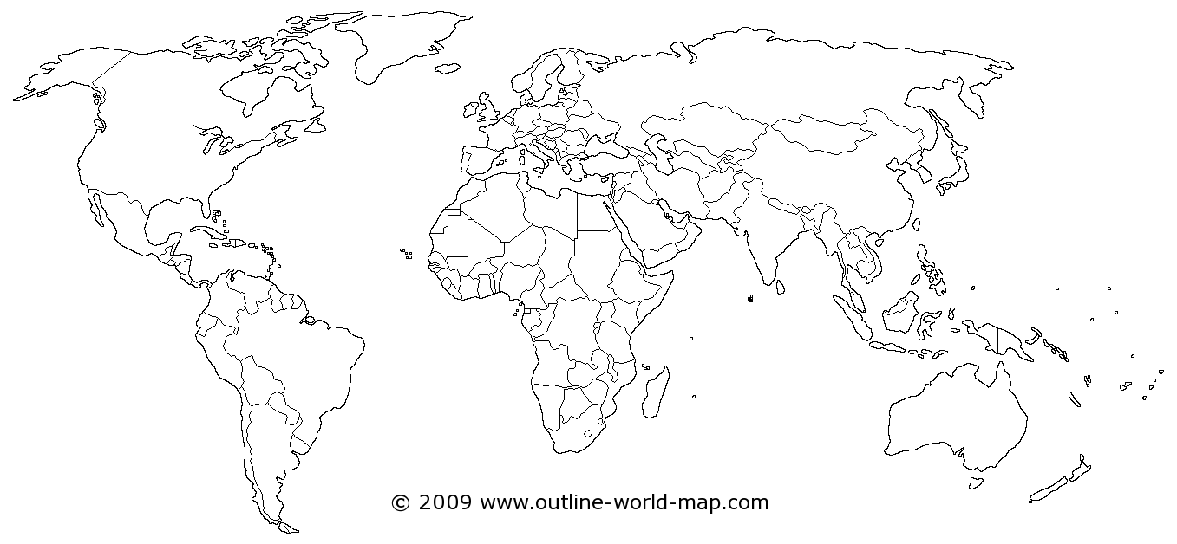](http://www.outline-world-map.com/white-transparent-political-world-map-b)

**Key:**