**Year Three Reading Lesson 4**

**Carnival**

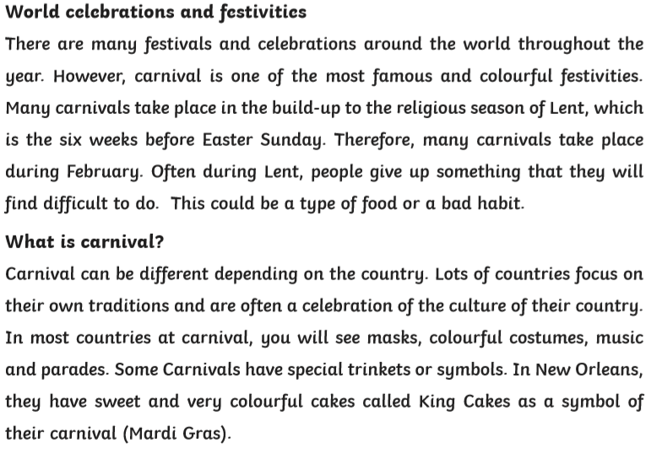

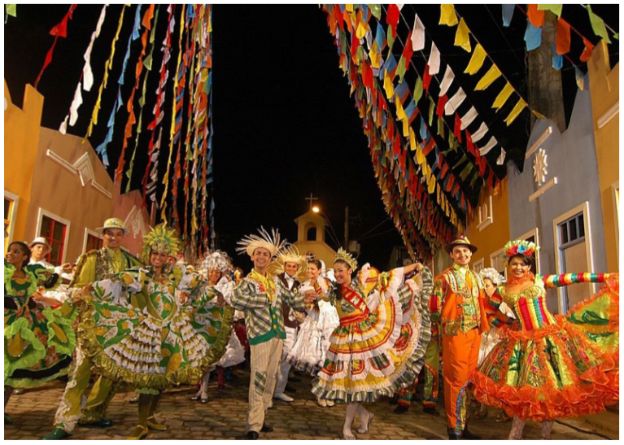

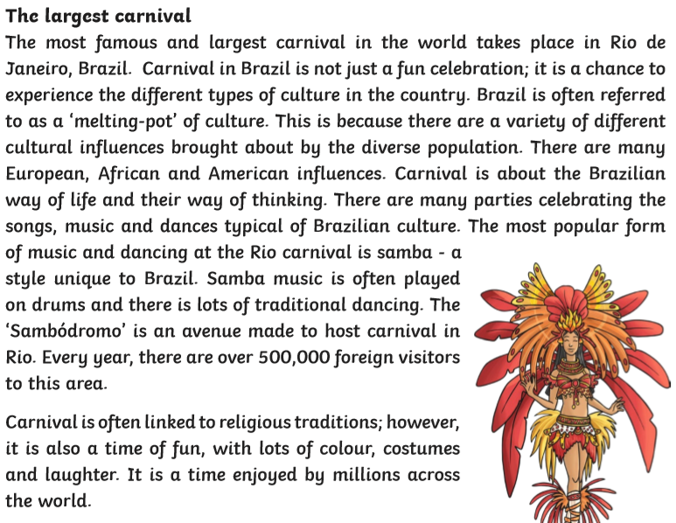

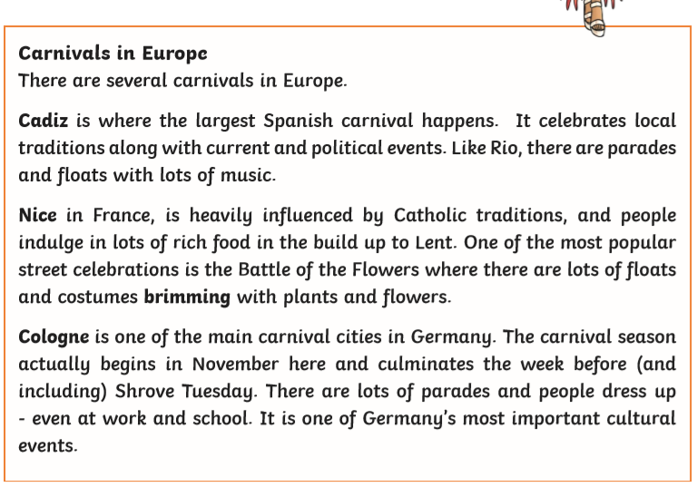

**Mixed Comprehension Questions**



  
  
  
  
  
  
  
  
  
  
  
  
  
  
  
  
  
  
  
  
  
  
  
  
  
  
  
  
  
  
  
  
  
  
  
  
  
  
  
  
  
  