Blue Pathway Home Learning w.c. 01.06.20
English Focus: Awesome, Amazing, Animals
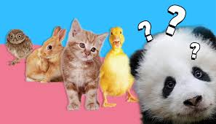
1. Favourite animal
I know how much you all love animals. Choose your favourite animal and write a description of it.
What does it look like? How fast is it? What does it like to eat?
Remember to draw the animal as well.
CHALLENGE YOURSELF: Can you fold your paper up to make a little information booklet?
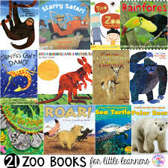
2. Famous animals in stories
Think of all your favourite books and stories. Which ones have animals in them?
Who are your favourite animal characters?
Draw a poster with all of your favourite animal characters on
CHALLENGE YOURSELF: Can you write a short poem about one of the animals?
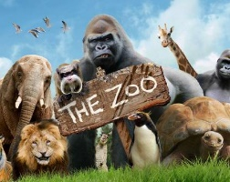
3. Build your own…Zoo!
You are going to open your own zoo/safari park. What animals are going to be in it?
Make an advert/poster persuading people to come and visit your fantastic zoo.
CHALLENGE YOURSELF: Turn your poster into a little leaflet telling people about all the different areas in your zoo.

4. The Zoo Review
Imagine you are writing a review of the zoo you created yesterday.
Tell the reader about all the amazing things you saw and did at your zoo.
CHALLENGE YOURSELF: film yourself reading out your review and post it on the class blog!
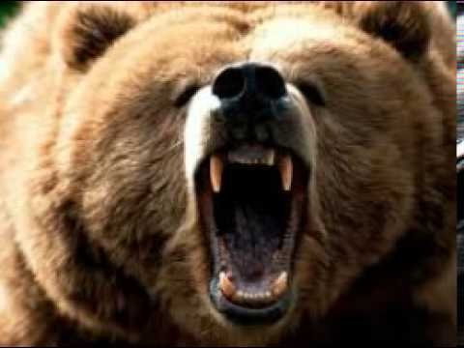
5. Scary animals
Imagine you are meeting a very big, very scary animal for the first time.
Write a description of what you can see and how it makes you feel!

Blue Pathway Home Learning w.c. 01.06.20
Topic Focus: Awesome, Amazing, Animals
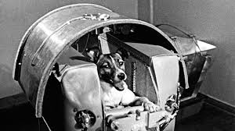
History: Laika the dog
Watch the video https://www.youtube.com/watch?v=9rf6ai59OA4
Write down what you think it might have been like for Laika the Dog to be the first dog in space.
How did Laika feel when she was in space?

Science: The animal challenge
Choose 3 different types of animals eg. birds, fish, repltiles, mammals, insects
How many can you list in each category in 5 minutes?
Make sure you time yourself and post your scores on the Resource Base blog!

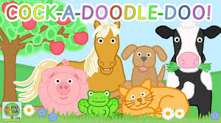
Music: animal sounds!
Make a musical carnival of all the different animal sounds.
What household items could you find to make an animal sound?
Think about what sounds they make when you do different things eg bang them, tap them, shake them.
P.E.
Have you worked out with Joe Wicks yet this week? If not, this is your day!! Go to Joe Wicks website and make sure you get
your heart pumping. Let’s keep fit!
https://www.youtube.com/channel/UCAxW1XT0iEJo0TYlRfn6rYQ
Topic: Animals
Find your favourite film or TV show with animal characters in it and have a film afternoon
Remember to get the popcorn in and get as comfy as possible!
Post a picture on the Resource Base blog of your brilliant film watching set ups.

Blue Pathway Home Learning w.c. 01.06.20
Maths | White Rose Maths: Scroll down the home page and go to the week marked Summer Term Week 6 (w/c 1st June). We are completing this learning this week.  https://whiterosemaths.com/homelearning/year-2/
Practical Maths Activity  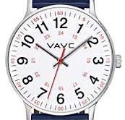 | Ask if you can borrow a timer or a watch with a second hand. How many seconds are there in a minute? How many things can you do in 1 minute? You could try hopping on one leg, running round your garden or writing your name.  Now think about all the minibeasts you have seen or read about. Time yourself for 5 minutes. How many can you think of? You could do this with your family and make it into a competition or just do it on your own. Try it again at the end of the week. Have you increased your knowledge?

