Ana Green Pathway Home Learning - English w.c. 29.06.2020
 | English: ‘Summer in the city’.
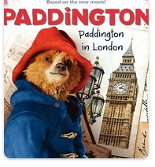 | Paddington in London!  Have you seen Paddington movie? It is quite fun!  Have a look at this London Pop up Book, what famous buildings can you see? Have you been to any of those places?  Why don’t you try to make your own book with London photos?  Resources: London minibooklet and London landmarks photos  CHALLENGE YOURSELF: Write the names of the landmarks underneath.
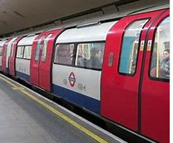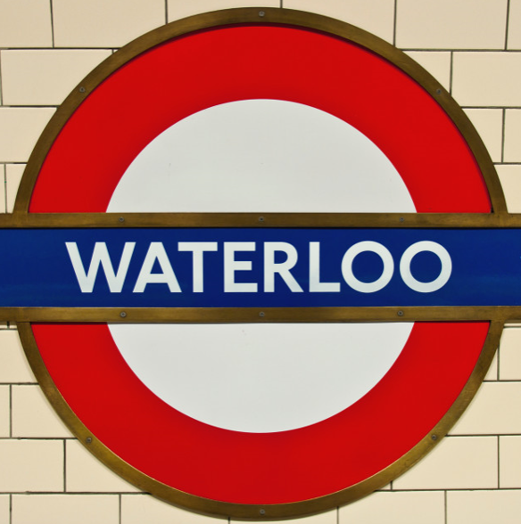 | Travelling in London  Let’s explore different ways of travelling around London.  First, have a look at this video about the London Underground https://youtu.be/9s6by6xJsUk  It goes fast, right? What would you have to do if you travel by tube? Have a look at this pictures, can you put them in the right sequence? Resource: Underground journey  CHALLENGE YOURSELF: You could design your own underground station symbol and give it a name
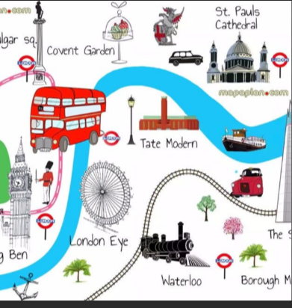 | London Bus  Now have a look at a London bus video https://youtu.be/cxZmWDuUPAg  Do you remember our Naughty Bus story? https://youtu.be/sqQ1BAEj1oE  Now design your London bus journey. Have a look at the picture.  You could use the Resource: London word mat and put the pictures along the map.  set up a London bus by putting together a line of chairs and providing a steering wheel for the driver and bag for the ticket collector  CHALLENGE YOURSELF: Discover the buses in your area. What numbers are they? Where do they go?
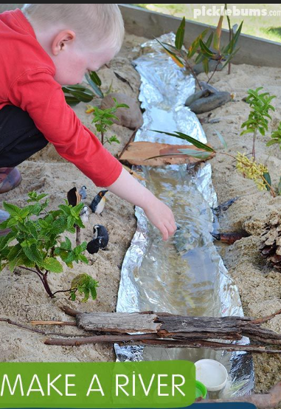 | Thames Boat  Make a river in your garden. Imagine it is the river Thames. You can use lego bricks to build buildings on both sides of the river banks. You can also put little trees, bridges, animals, pebbles…  CHALLENGE YOURSELF: Here is other pictures of river crafts you can make  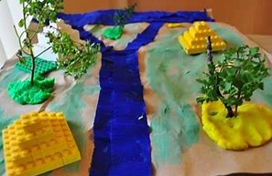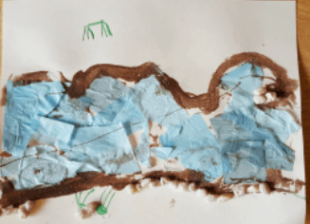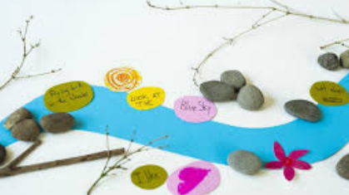
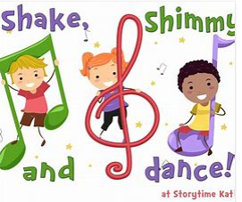 | Music time!  Let’s recap some of our favourite songs  Warm up with this fun song https://youtu.be/TSdeIhmv6v0  Shake your sillies out https://youtu.be/NwT5oX_mqS0  Boom chikka boom https://youtu.be/F2XVfTzel8E  CHALLENGE YOURSELF: Please tell us which song you like best!

Ana Green Pathway Home Learning - Writing w.c.29.06.2020
 | Learning linked to theme of ‘Summer in the city’.
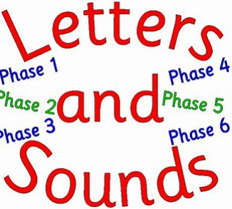 | New sound to practise  This week we are going to focus on the ‘ai’ sound: train, rain, pain.  Have a look at this video https://youtu.be/JDzpV3jFefs  You can also practice ai sound playing this game: https://www.phonicsplay.co.uk/resources/phase/2/buried-treasure +ai  CHALLENGE YOURSELF: complete ai sound worksheets
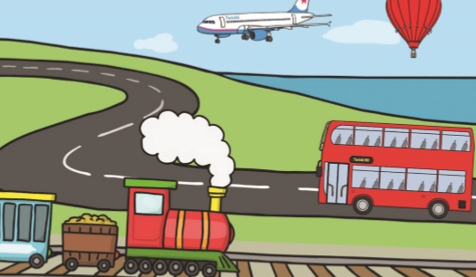 | Time to work “Transport writing”  Have a look at the pictures in this activity. They are all ways of transport. Can you match the words and the pictures? Remember you can use the knowledge of first sounds to find the right word.  Resource: Transport writing activity  CHALLENGE YOURSELF: Can you add any other way of transport?
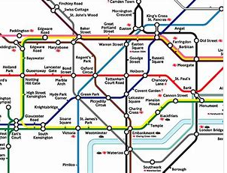 | Finger gym  Remember to keep on practicing our finger gym as a warm up https://www.youtube.com/watch?v=3VpARNgbb8c  Have a look at a london tube map. What do you see? Lots of different colour lines and names of the stations.  Why don’t you try to draw your own tube map? Use different colour pens, crayons, paint brushes, felt pens.. for your design.  CHALLENGE YOURSELF: You can also think about new names for the tube stations
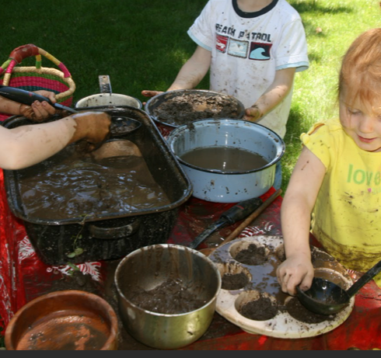 | Messy play!  We know messy play is great fun but we also know that activities such as pouring, shovelling or drawing in the sand help build strength in the large muscle groups at the top of the arms and it is these muscles that then enable the smaller muscles in the hands and fingers to make precise and controlled movements. So it is great for our fine motor skills!  Making mud pies: To make great mud pies, you need to use good smooth dirt that is free of sand, rocks and pebbles. In a small bucket mix the dirt with water. Using your hands to combine the dirt and water, continue add small amounts of water until the mud is the consistency of bread dough. Have fun!
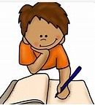 | Writing time  Recap cvc words by playing this game http://www.literactive.com/Download/live.asp?swf=story_files/hanging_monkeys_US.swf then complete  Resource: cvc words writing  CHALLENGE YOURSELF: Please recap again all sounds learnt so far https://youtu.be/DIpcahxNSU4 https://youtu.be/vU2vWZKS7rY
Ana Home Learning – Maths, Science and Topic w.c. 29.06.2020
Maths: time  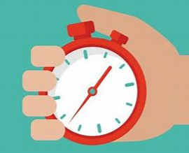 | - Have a look at the clocks around home. Look at the numbers and the hands. Then make you own one! Resource: clock face template. You can use other things too  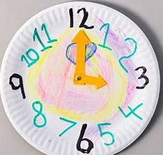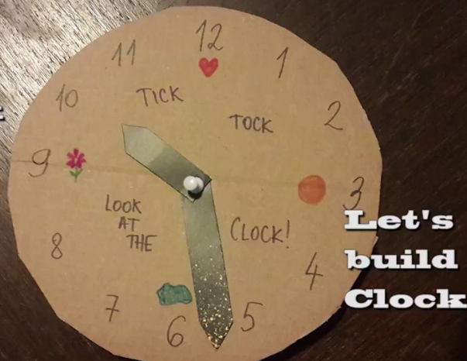  - Talk about the sequence of the day, First… Then… Then complete Resource: How do you questions and answer cards.  - 1 minute challenge : how many star jumps, how many times can you write number 2, how many times can you touch your toes, say your name… make a list! Look at the numbers, which one is bigger, smaller, the same… what about two minutes challenge!  - O’clock time! Look at this video https://youtu.be/rWdN81cuqG8 then you can practice with Resource: O’clock matching cards.  - Play O’clock time here https://www.topmarks.co.uk/time/teaching-clock , think about what time you get up, have breakfast, lunch, play time, home learning time.... then complete Resource: O’clock matching times of the day
Practical Maths Activity  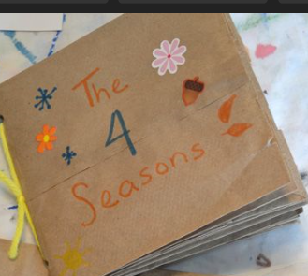 | ‘My book of 4’  I would like you to enjoy collecting objects and counting them this week. Your parents could ask you to choose your favourite number. Then you can collect four/five… (depending on the number you have chosen) of a range of objects both indoors and outdoors, leaves, stones, play figures, photos, stickers ….and create your own book by sticking your objects in a plain-page book. While you are collecting just think: Do I need any more? Do I have enough? Have I got too many?
Science | Freezing and melting: Lego Ice excavations  Pour water into a storage container, add lego bricks ( or anything else you fancy ), leave in a freezer until frozen. How long did it take? Then use plastic glass, syringes…to pour water over your ice. Science questions to ask: what happens when you use hot and cold water? Where could you leave the ice to melt on a sunny day? Will the water freeze again if you put it back in the freezer?
Mindfulness | Blowing Bubbles  Blowing bubbles. Have your kids focus on taking in a deep, slow breath, and exhaling steadily to fill the bubble. Encourage them to pay close attention to the bubbles as they form, detach, and pop or float away.
Speech and Language | Listening  Listening treasure box : Collect lots of things that make a noise,such as: crinkly paper, noise making toys, pots and pans, musical instruments, books with noise buttons…Explore! Listen and talk about them.
Everyday activities | Reading, phonics / spelling, times tables, number bonds  KS1: Phonics and spelling - https://www.bbc.co.uk/bitesize/subjects/zgkw2hv maths - https://www.bbc.co.uk/bitesize/subjects/zjxhfg8
Dates to research this week | 4th July  American Independence Day  &  Alice’s Day  A to celebrate Lewis Carrol’s most famous character, Alice. Read/Watch the film of Alice and her adventures to wonderland.  https://www.youtube.com/watch?v=Y-0JC28xxTY
(Creative arts activities are on a separate sheet).

