Ana Green Pathway Home Learning - English w.c. 08.06.2020
 | English: ‘Awesome, Amazing Animals’.
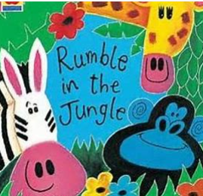 | Story time: There is a Rumble in the Jungle  https://www.booktrust.org.uk/books-and-reading/have-some-fun/storybooks-and-games/rumble-in-the-jungle/  Enjoy reading the story again, then revisit the order in which animals appear. Can you put the animals in the right order?  Use the following Resource: rumble in the jungle sequencing  CHALLENGE YOURSELF: You could use ordinal number First, second, third, fourth…and finally... while ordering the story
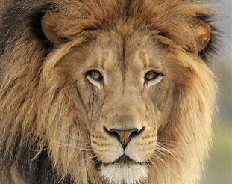 | Lion dance and Craft  Have a look at the lion page in our story “The King of the Jungle” and pay attention to its features: teeth, claws, mane…  Use full sentences: The lion has big teeth, yellow and orange mane, long tale..  Enjoy and dance the Lion song https://www.youtube.com/watch?v=2mdB8JekKlU  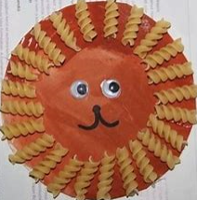 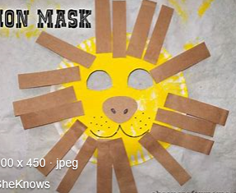 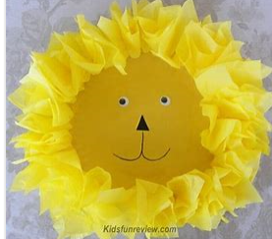 Make your own lion!  CHALLENGE YOURSELF: You could do some research abou lions, have a look at bitesize website https://www.bbc.co.uk/programmes/p018yxrr then have a go at labelling a lion Resources: lion labelling
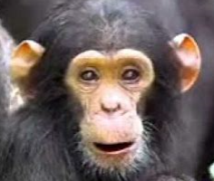 | Monkeys!  You can do some research about monkeys food https://www.bbc.co.uk/bitesize/clips/zgftb9q What do they like to eat?  Dance the monkey song https://youtu.be/heTzUg_eIes It’s got a great rhythm  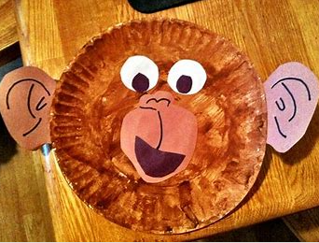 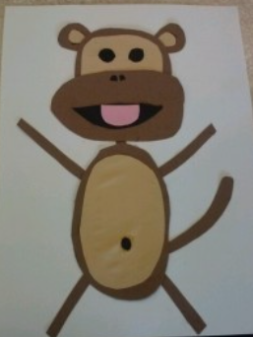 Make your own monkey!  CHALLENGE YOURSELF: Make sure the Monkeys share their food! Resource (Monkey sharing food 3 documents)
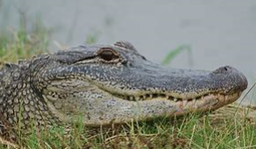 | Crocodile, snakes…. Reptiles!  You can learn more about reptiles on the bbc bitesize website https://www.bbc.co.uk/bitesize/topics/z6882hv/articles/zp9pfg8 there are also nice games to play!  Make a crocodile craft using egg cartons, pegs, a box…  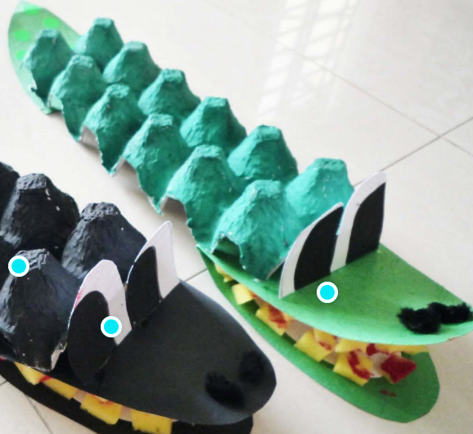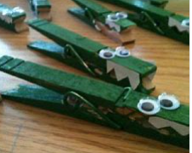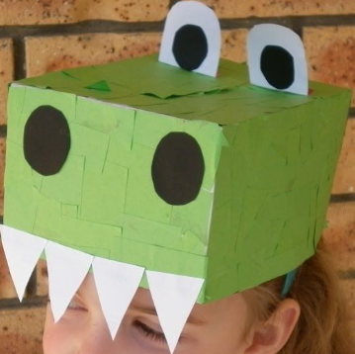  CHALLENGE YOURSELF: Crocodile rock dance! https://youtu.be/5J1LixIs7lw
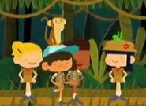 | Walking in the jungle!  Do you remember one of our favourite dance? https://youtu.be/GoSq-yZcJ-4  Think about all the actions we have to perform in the song: walking, jumping, skipping… The actions are the part of the sentence that really tell us what we have to do!  Complete Resource: verbs and photos matching cards  CHALLENGE YOURSELF: Yoga safari https://youtu.be/C4CaR0syf1g

Ana Green Pathway Home Learning - Writing w.c.01.06.2020
 | Learning linked to theme of ‘Awesome, Amazing Animals’.
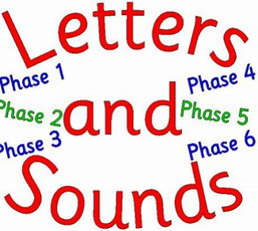 | Sound to practise  Th https://youtu.be/7f74GArsWis  Game: Dragon den, please follow the lins to letters and sounds phase 3 website, then select +th sound https://www.phonicsplay.co.uk/DragonsDen.html
Th alphablocks  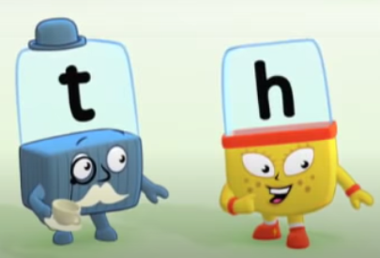 | Time to work  Have a look at the th sound alphablocks video https://youtu.be/OB43Qgu2Oac  Then try Th sound workbook sounds activity Resource
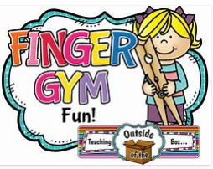 | Fingers warm up  You can use straws, spaguetti, pencils.. and cheerios, hula hoops, buttons.. it is a really good finger gym and coordination activitiy.  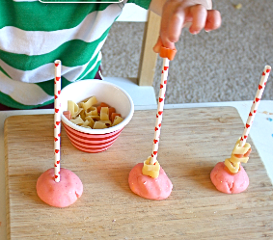
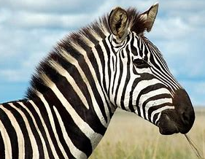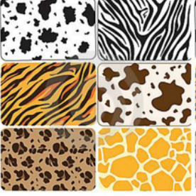 | Time to draw a zebra face  I’d like you to pay attention to the video https://youtu.be/zactRmxx_qc and copy the shapes to make a lovely zebra face  CHALLENGE YOURSELF: You can learn more about animal patterns here https://www.bbc.co.uk/bitesize/clips/zpn6n39  Have a go at drawing those patterns!
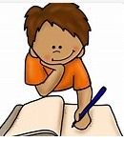 | Writing time  G, o, c, k letters writing practice  Resource: g o c k writing booklet  CHALLENGE YOURSELF: You can try to write cvc words with the sounds we know: cat, sat, mop, toc, mat…

Ana Green Pathway Home Learning – Maths, Science and Topic w.c. 08.06.2020
Maths | White Rose Maths: Scroll down the home page and go to the week marked Summer Term Week 5. We are completing this learning this week: Compare length and height  https://whiterosemaths.com/homelearning/year-1/
Practical Maths Activity  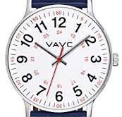 | Measuring…  Have a go at comparing the capacity of the different things in your home. Make predictions about how many cups of water you think different containers will hold, then see if you were right! Which one held the most amount of water?  You could also have a go at sorting out your toys/teddies and arranging them from shortest to longest. Have fun!
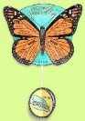  Science | Animals and their habitats  Would you like to make a hotel for bugs? https://youtu.be/OexxoXo9uFk You could also look for hotel bugs if you go to the park  Print out the Resource: Bug hotel Poster so everyone can see where your hotel is.  CHALLENGE YOURSELF: You can learn more about minibests on the BBC bitesize website. https://www.bbc.co.uk/bitesize/topics/z6882hv/articles/z9fkwmn
Speech and Language  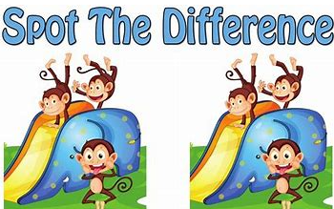 | Interaction  We communicate and interact with each other in different ways; learning the skills of interaction is really important for having good conversations.  Play “What is different?” Get your child to look at you carefully and then ask them to close their eyes. While they are not looking, change something about your appearance, like rolling up your sleeves, messing up your hair or putting on some glasses. Can they spot what is different?
Well-being / PSHE  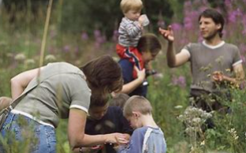 | Mindfulness  Safari  The Safari exercise is a great way to help kids learn mindfulness. This activity turns an average, everyday walk into an exciting new adventure.  Tell your kids that you will be going on a safari: their goal is to notice as many birds, bugs, creepy-crawlies, and any other animals as they can. Anything that walks, crawls, swims, or flies is of interest, and they’ll need to focus all of their senses to find them, especially the little ones (Karen Young, 2017). You can take magnifying glasses or a camera if you have one!
Everyday activities | Reading, phonics / spelling  KS1: Phonics and spelling - https://www.bbc.co.uk/bitesize/subjects/zgkw2hv maths - https://www.bbc.co.uk/bitesize/subjects/zjxhfg8
Dates to research this week | Saturday 20th of June: Summer Solstice, the longest day of the year!
(Creative arts activities are on a separate sheet).

