Ana Green Pathway Home Learning - English w.c. 01.06.2020
English
‘Awesome, Amazing Animals’.
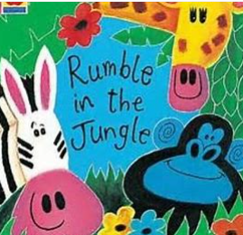 | Story time: There is a Rumble in the Jungle https://www.booktrust.org.uk/books-and-reading/have-some-fun/storybooks-and-games/rumble-in-the-jungle/  Who, What doing, What, Where  While you are reading the story, stop and look at each page, Who is there, What is it doing?, Where is it?  CHALLENGE YOURSELF: Can you describe the animal using adjectives? “The big elephant is looking at me in the jungle!”.
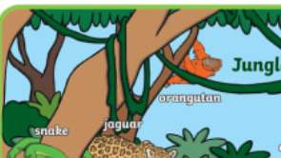 | Making a jugle  Have a look at all the animals in our story and the mat provided. Can you see if there are animals missing? Can you add them to the scene?  See Rumble in the Jungle word mat and Rumble in the Jungle Scene mat  CHALLENGE YOURSELF: Can you say where the animals are? By the river, on top of the tree…
Guess who?
Listen to the sound that an animal make and match it to the jungle animal.
What-am-i-jungle-animal-powerpoint
CHALLENGE YOURSELF: ICT time! https://www.sheppardsoftware.com/preschool/animals/jungle/animaljunglegame.htm
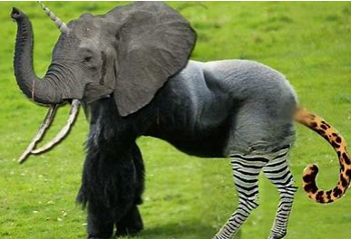 | Animals ‘Mash-up’ (does not involve ‘mashing up’ animals!)  Choose two animals and jumble up their features to create a new one.  Draw it, label it and give it a suitable name…  CHALLENGE YOURSELF: Can you give your animal a new name? “The Zelephant”
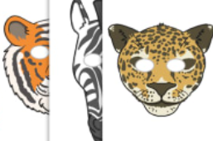 | Time to Role Play!  rumble-in-the-jungle-role-play-masks  Have a look at masks. Which one do you like better? Can you wear it and pretend to be the animal?  CHALLENGE YOURSELF: Where does your animal live? What does he eat? Would you give a mask to your brothers and sisters, parents and make a jungle at home?

Ana Green Pathway Home Learning - Writing w.c.01.06.2020
 | Learning linked to theme of ‘Awesome, Amazing Animals’.
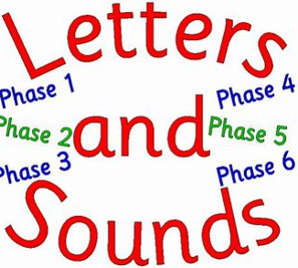 | Sound to practise  Sh https://youtu.be/7gBsGxhdt2E  Game:  Dragon den, please follow the lins to letters and sounds phase 3 website, then select +sh sound https://www.phonicsplay.co.uk/DragonsDen.html
The selfish fish  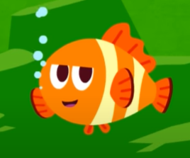 | Time to work  Ch and Sh sounds activity  Have a look at the selfish fish video https://youtu.be/8y2V_keGtuM  Then try Ch and Sh sounds activity!
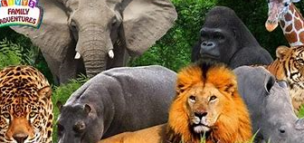 | Animal Parade time!  You can draw different lines on a piece of paper: circle, zig-zag, curved.. then line up your animal to create an animal parade! It can also be any objects you find at home: cars, lego bricks, little pieces of paper, grass, pebbles…  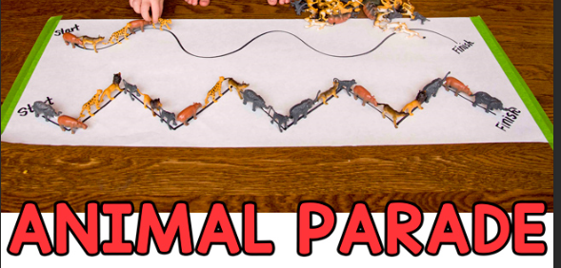
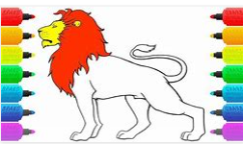 | Time to colour in your favourite animals  Have a look at the different colours and characteristics of the animals, then have a go at colour them in!  rumble-in-the-jungle-colouring-sheets  CHALLENGE YOURSELF: Don’t forget to write their names underneath.
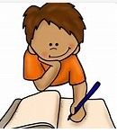 | Writing time  i, n , m , d letters writing practice  letters-and-sounds-workbook-i-n-m-d  CHALLENGE YOURSELF: You can try to write cvc words with the sounds we know: sat, pin, tap, mad, I am..

Year 1 Home Learning – Maths, Science and Topic w.c. 01.06.2020
Maths | White Rose Maths: Scroll down the home page and go to the week marked Summer Term Week 6 (w/c 1st June). We are completing this learning this week:  https://whiterosemaths.com/homelearning/year-1/
Practical Maths Activity  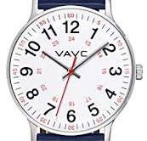 | Bake together. Talk about the weight of flour, the volume of milk, number of eggs, the amount of time the cakes will bake for, how hot the oven will be.
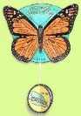  Science | Animals and their habitats  https://www.bbc.co.uk/bitesize/topics/zx882hv  In the BBC Bitesize website you will discover lots of videos about different animal habitats and games to play!  Have a look at them. You can then complete the activity: habitats and their habitats matching activity.  animals-and-their-habitats-matching-activity
Speech and Language  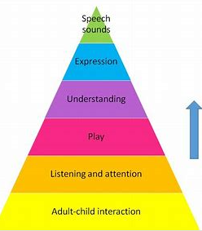 | What’s in the bag?  A great guessing game!  Put a few things in the bag from around the house - like a coin, a fruit, a toy car, a pencil, a rock, etc. You could also put some animals from the story or favourite toys.  Let your child reach into the bag and choose an object. Encourage them to feel it, roll it in their hands and imagine what it might be.Ask them to guess before pulling it out.
Well-being / PSHE  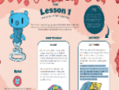 | What makes you awesome and amazing? Hidden talents etc. Draw yourself and let everyone tell you how amazing you are! You can do this with the rest of your family too.  Our differences are what make us all amazing!
Everyday activities | Reading, phonics / spelling  KS1: Phonics and spelling - https://www.bbc.co.uk/bitesize/subjects/zgkw2hv maths - https://www.bbc.co.uk/bitesize/subjects/zjxhfg8
Dates to research this week | 5th June: World Environment Day
(Creative arts activities are on a separate sheet).

