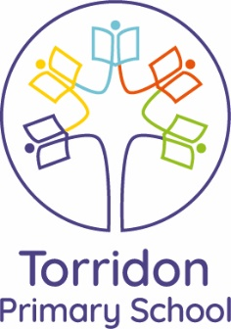
Y1 Spellings
Focus: ‘sh’ and ‘ng’ digraphs
Date set: 14.09.18

Phonics play:
Have a go at playing ‘Buried Treasure’ on the website: www.phonicsplay.co.uk.
Select phase 3 and play with words containing the digraph ‘sh’ and/or ‘ng’.
Can you sort them into real and alien words?

Have a go at writing the words that come up:
____________________________________________________________________________________________________________________________________________________________________________________________________________________________________________________________________________________________________________________________________________________________________________________________________________________________________

