Y6 Maths Home Learning
Focus: Rounding
Date set: 14.09.18
Date due: 20.09.18
Reminder:
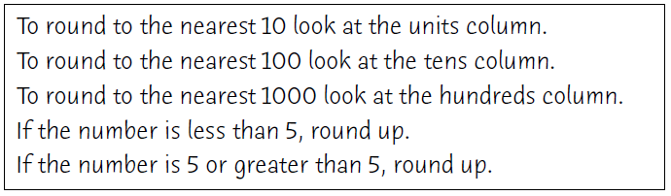
Practice:
