Dear parents and carers,
Phonics
This week we have been revising the sounds a, i, m, s, t, n, o and p. After half term we will introduce the third unit, focussing on the sounds:
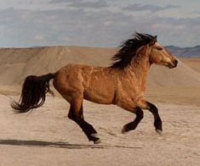
b (balls are bouncing)
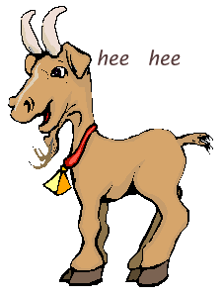
c (caterpillars curling)
g (goats are giggling)
h (horses are hot)
We will learn to put the sounds together to make words e.g.
bag, can, gap, cap, cot, bat, hit, hop, ham, pig and tap.
We will also recap the sight words I, is, a, the.

Class Fund

Thank you to all parents who have returned the class funds. As a reminder, we are asking parents to make a voluntary contribution of £2 for the Autumn term to our class funds. This is used to buy ingredients for play dough and cooking, and other consumable resources. Please place the money in the attached envelope.

Parent and carer open evenings
Please make sure that you have signed up for a time slot to meet with your child’s class teacher on Tuesday 16th October or Thursday 18th October.
Many thanks,
The Reception Team.

