Phonics

Dear parents and carers,
This week the children have enjoyed our daily phonics lessons focussing on the first unit of sounds: a, i, m, s, and t. Next week we will introduce the second unit which includes the following letter sounds:
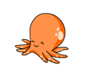
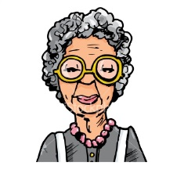
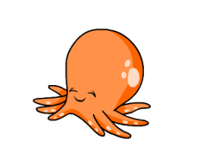

n (nan) | o (octopus) | p (popcorn)
The children will learn to put the sounds together to make words using the sounds taught in the first two units a, i, m, s, t, n, o and p. e.g. pan, pot, tap, mat, sat, sit. We also learn how to chop the words up into their sounds
e.g. p - a - n pan
Please cut out the letters in this pack and use them to make simple words, as above.
You can support your child at home by learning the jingle and the actions; looking for these sounds in books or on signs; and playing ‘I Spy’ with the letter sounds (not the names).
We will also be teaching the children ‘sight’ words. These are words that the children will learn to read and not sound out.
Next week we will introduce the words I, is and a.
Maths
In Reception we are learning to recognise and order numbers 1-20 and beyond. Please continue to encourage your child to look out for numbers at home or in the environment. You might like to use the attached numbers and go on a number hunt at home or have a go at putting the numbers in order.
You could also talk to your child about numbers of particular interest, for example their birthday, their age, the age of siblings or relatives, their door number or bus numbers. Have fun!

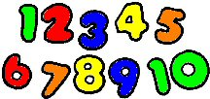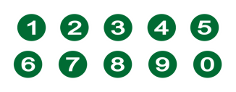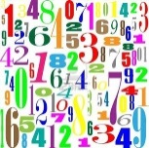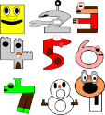

Junk Modelling
We are always needing recycled materials for our junk modelling. Please can you bring in any cardboard boxes, cardboard rolls, plastic containers, bottle tops and place them in the net outside.

Many thanks,
The Reception Team.

