Phonics

Dear parents and carers,
Next week we will be beginning our daily phonics lessons. We will begin with Unit 1, with the following letter sounds:
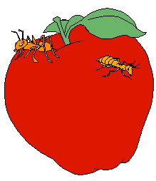
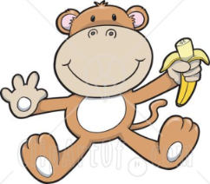
a (ant)
i (insect)
m (monkey)
s (snake)
t (tiger)
We will learn to say and read the letters as a sound (rather than the letter name).
Please check this website for the correct pronunciation of sounds: https://www.youtube.com/watch?v=IwJx1NSineE
We will learn to put the sounds together to make words e.g. mat, sat, sit, pin, tin. We will also learn how to chop the words up into their sounds e.g. s -a -t .
Please cut out the letters in this pack and keep them. (Eventually you will have collected all of the letters). Please use them with your child at home to make simple words, such as .
In addition, for each sound we will learn a jingle which we sing with actions (please see the accompanying sheet).
You can support your child at home by learning the jingle and the actions, looking for these sounds in books or on signs, and playing ‘I Spy’ with the letter sounds (not the names).
Reading
Your child needs to have their book bag in school every day. They will be bringing home a ‘story book’ and their Reading Record book in their book bag. Please try to share a book every day and write regular comments in the Reading Record book.

Many thanks,
The Reception Team.

